Mechanical Engineering Senior Design Project

(ME SDP)

**ME SDP305: Robotic Arm for NES Power Glove**

**Design Report**

***Client: TechWorks!***

*Date: 5/7/2025*

*Revision: C*

*Submitted by:*

*John Milham, Mechanical Engineer*

*Maxine Krueger, Mechanical Engineer*

*Nicholas Marzan, Mechanical Engineer*

*Ragul Ganesh Anitha Palanivel, Computer Engineer*

*Faculty Advisors:*

*Dr. Lee, Jaeho*

*Professor, Selleck, Colin*

*Approved for public release; distribution is unlimited.*

*Submitted in partial fulfillment of ECD academic requirements.*

*Thomas J. Watson College of Engineering and Applied Science*

*Binghamton University*

*Binghamton, NY*

**Executive Summary**

The fundamental purpose of ME SDP 305: Robot Arm for NES Power Glove project is to create a controlled robot arm that fully displays the capabilities of the NES Power Glove for a museum display at TechWorks! The robotic arm is to be controlled by another glove made by ECD 526, which will be able to be used by guests to play the NES game Super Glove Ball without the risk of damaging the Power Glove. The major requirements for this project included the following: the fingers shall extend a full 180 degrees, the arm’s pitch and yaw should be 90 degrees (+/- 45), the wrist shall rotate 90 degrees, the fingers should curl 90 degrees at each joint, the movement of the arm should be uninterrupted, and the Power Glove should be able to fit onto the hand. Additionally, the project must be completable within an allotted budget of $1,000. The arm will be 3D printed using a polycarbonate carbon fiber composite filament (PC-CF). The arm will feature 4 main connecting components: the shoulder/base, the forearm/wrist, the hand, and the fingers. The shoulder piece will house 2 60 kg servos, with each one being responsible for either the pitch or yaw of the arm. The shoulder will also include a compartment to house a 4.5 kg weight to add stability to the structure while moving. The forearm will shelter 4 12 kg servos that will each control one finger’s movement by rotating the servo horn clockwise and counter-clockwise to pull braided fishing line connecting to each finger. Braided fishing lines allow for high breaking strength, no shape memory, and less elasticity than the monofilament used by the previous design. The wrist portion of the forearm will have space for the last 12 kg servo, this one responsible for the wrist rotation. The wrist will also feature 2 gears (with a 4:1 ratio) to assist with this rotation. A wrist cover piece tops off the arm part and allows for connection of the hand. The hand is hollowed out from the bottom to allow space for the braided fishing line to run up to the fingers. Because of this, however, it features a pole-like piece that extends downwards from the top. This pole will connect to the gears in the wrist through a corresponding hole in the wrist cover piece, allowing the hand to be fastened onto the arm and able to rotate accordingly. The palm is also curved in a concave fashion to allow for the glove to fit easier, as the fingers will be able to close in a clasping fashion. The hand piece also features finger holes with corresponding slots for the finger hinges, which connect to the bottom portion of each finger to allow for bending. The fingers all feature the proper number of joints, though it is important to note that the pinky will not be actuated by a servo, as the NES Power Glove does not have a pinky input. The shoulder portion is also where the ESP32 microcontroller will sit. In-depth wire mapping has been done to ensure the wires are organized in a neat and aesthetically sound fashion in order to improve on the previous design. This ESP will communicate with the ECD 526’s controller glove. The bluetooth will receive positional data from the glove and parse this date to define specific positions for each servo. Flex wiring will be used with the servos to ensure the durability of the wires throughout the mechanism. Metal screw sleeves will be utilized within screw holes to ensure the damage done unto the PC-CF from steel screws is minimized. Material and design choices were properly verified through FEA analysis and other related dynamics calculations. 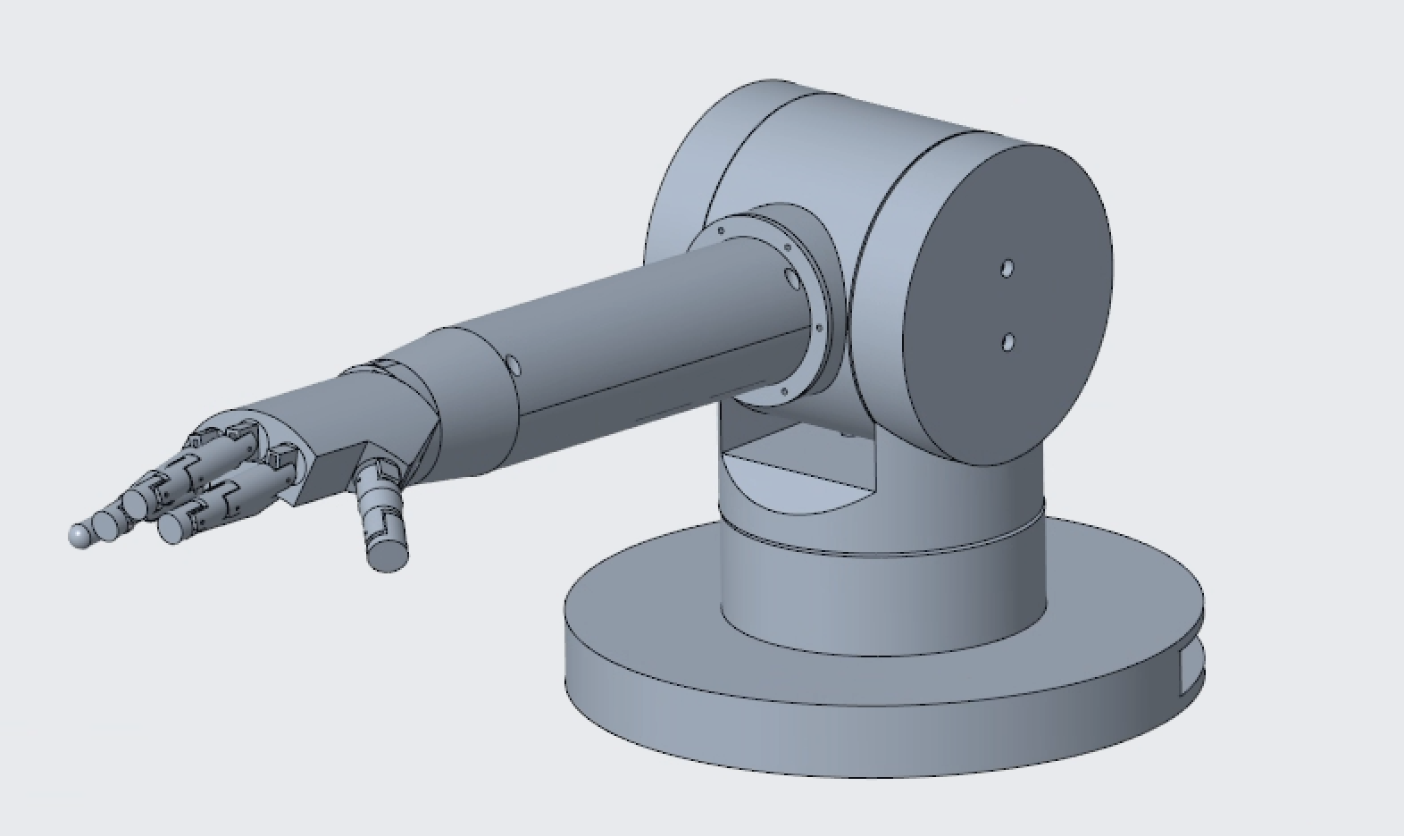

**Table of Contents**

1. Problem Statement….……….……………………………………………………5

1.1. Problem Scope ………………………………………………………………5

1.2. Technical Review ……………………………………………………………5

1. Design Requirements …………………………………………….………………5
2. Design Description ………………………………………………………………6

3.1. Overview ………………………………………………………….…………6

3.2. Detailed Description ……………………………………………...…………7

3.2.1. Fingers………………………………………………………….…7

3.2.2. Hand………………………………………………………...……12

3.2.3. Wrist……………………………………………….………..……14

3.2.4. Shoulder (Pitch)…………………………………….……………17

3.2.5. Shoulder (Yaw)…………………………………………………..23

3.2.6. Electronics………………………………………………….……25

3.2.7. Code…………………………………………………………...…26

3.3. Use………………………………………………………………………….27

1. Implementation……………………………………………….…………………30
2. Testing and Validation…………………………………………………………

5.1. Overview…………………………………………………………………..31

5.2. Testing and Results……………………………………………………… 32

5.3. Assessment……………………………………………………………….36

5.1. Schedule…………………………………………………………….………37

5.2. Finances………………………………………………………….…………41

1. Social Impact……………………………………………………………………42
2. References…………………………………………….…………………………43
3. Appendices………………………………………………………………………

7.1. Appendix A…………………………………………………………………44

7.2. Appendix B…………………………………………………………………45

7.3. Appendix C…………………………………………………………………46

7.4. Appendix D…………………………………………………………………54

7.5 Appendix E…………………………………………………………………55

**List of Figures**

Figure 1: Context diagram.

Figure 2: Index finger .stl files from InMoov.

Figure 3: CAD recreation of assembled index finger on its hinge.

Figure 4: 3D printed index finger.

Figure 5: Diagram of interior of finger.

Figure 6: FBD of simplified middle finger.

Figure 7: Previous ABS finger pin.

Figure 8: Deformation plot of PC-CF finger pin.

Figure 9: Index finger hinge.

Figure 10: Hand part top view.

Figure 11: Bottom view of hand.

Figure 12: Standard view of hand.

Figure 13: Wrist.

Figure 14: Top of wrist.

Figure 15: Wrist cover top.

Figure 16: Wrist cover bottom.

Figure 17: Back cover.

Figure 18: Rotating part of shoulder for pitch.

Figure 19: Servo in Rotating part of shoulder.

Figure 20: FBD of arm and rotary shoulder part.

Figure 21: Pitch shoulder connection.

Figure 22: 60kg servo horn boundary conditions.

Figure 23: 60kg servo horn deformation plot.

Figure 24: 60kg servo horn deformation values.

Figure 25: 60kg servo horn equivalent stress plot.

Figure 26: 60kg servo horn equivalent stress values.

Figure 27: Servo wire channel.

Figure 28: Rotational yaw part/stationary pitch part.

Figure 29: Shoulder base with 60kg yaw servo mounted.

Figure 30: Wire channel holes for high flex wire in rotational yaw piece.

Figure 31: Wiring diagram for shoulder.

Figure 32: ESP32 servo signal connections.

Figure 33: Data Flow Diagram: Split into the glove and arm

Figure 34: Data Flow Diagram: Glove.

Figure 35: Data Flow Diagram: Arm.

**List of Tables**

Table 1: Deadline schedule.

Table 2: Weekly task schedule.

Table 3: Deadline Gantt Chart.

Table 4: Weekly task Gantt Chart.

Table 5: Finance table.

**1. Problem Statement**

**1.1 Problem Scope**

The problem is to create and improve upon the robotic arm design project from last year, ECD 416. The new robotic arm design must be compatible with a vintage NES Power Glove controller so that the NES Power Glove can be put on display and used to play the NES game “Super Glove Ball” in the Techworks! museum. This is to prevent damage to the glove due to human utilization.

The team explored methods of manufacturing the robotic arm having longevity and maintenance at the forefront of our research while also remaining vigilant of the remaining concerns with the electronics, since last year's robotic arm design had issues with these design elements. The team decided to focus more heavily on longevity and maintenance since the robotic arm senior project is split into two teams, SDP 305 which is this project and less electrically focused, and the other team ECD 526 works on the controller for the arm, and is focused more on electronics.

Our team has been in communication with each other as well as our corresponding team to decide what the best course of action would be to improve upon the old robotic arm design from last year. Each week our individual team first meets with our faculty advisor, then afterwards discusses the planning and dividing the work for the week, in order to present what has been accomplished to our faculty advisor the following week. Although meeting with our corresponding team happens less often, it was still necessary to meet with them and hear their perspective on how we could approach issues.

**1.2 Technical Review**

Robotic arms have been used in industry to handle tasks that are considered repetitive, need a high level of precision and accuracy, require prolonged productivity, and a variety of other tasks that a human may find difficult to perform. Overtime, these devices have evolved into versatile tools that serve a variety of functions.

The Unimate, created in 1954 by George Devol, was the first programmable robotic arm. The Unimates usage in General motors assembly lines demonstrated the potential of robotic arms being used in industry.

Although perhaps not as significant as the Unimate, the robotic arm design for project SDP 305 embodies some of the general purposes that robotic arms have in industry, specifically focusing on precision since the NES Power Glove is a vintage item that can be upwards of $250.00 [8], and it becoming damaged while being used to play games at the Techworks! museum would require the glove to be replaced.

**2. Design Requirements**

The first design requirement is that the arm must be compatible with the NES Power Glove. This is because the glove will be used to play the game “Super Glove Ball” for the purpose of the museum display at Techworks!.

Another requirement is the movement of the fingers. The fingers can fully extend and curl to the extent that the sensors in the power glove can detect. There are a total of 2-bits per finger, and there are 4 fingers that have sensors in them. The pinky is the only finger on the glove that has no sensor input, so for the purpose of this project, the pinky does not need to move.

The next requirement is for the rotation of the wrist. The wrist must be able to roll 90 degrees in either direction, for a total of 180 degrees of movement. One of the movements that NES Power Glove can detect is the rolling of the wrist, so allowing the robotic arm to emulate that movement is important for compatibility purposes.

The next requirement is for the movement of the arm. The arm must be able to pitch and yaw 45 degrees in either direction. These arm movements are detectable by the NES Power Glove, and need to be implemented for the purpose of compatibility.

The next requirement is that the arm must be responsive to controller inputs, to support playing the “Super Glove Ball” NES game. This requirement is meant more for our corresponding team, ECEME 526, but requires the compliance and collaboration of our team SDP 305.

The budget for this project is $1,000.00, so the design that our team creates must fulfill all the above requirements while remaining within the allotted budget given.

**3. Design Description**

**3.1 Overview**

The Arm/Wrist subsection of the robotic arm was designed to house five 12kg/cm servos, one for wrist rotation, and one per finger except the pinky. Each finger is connected to its corresponding servo via two braided fishing lines. One of the fishing lines is responsible for the curling motion of the fingers, while the other is responsible for bringing the fingers back to an uncurled state. The hand subsection is connected to the wrist by a wrist cover part. There is a gear located on the bottom of the hand part as well as one on the servo responsible for wrist movement. The ratio of the gears is 4 to 1, so that the hand can rotate 90 degrees in either direction. The wrist and arm subsection was also designed with containing wires in mind. Located underneath all the servos that control the fingers are channels that allow the wires to be organized and contained.

The electronics for the project are to power each of the servos, and the ESP32. In total, there are five 12kg/cm servos in the arm/ wrist and two 60kg/cm servos in the shoulder.

Carbon fiber composite filament has a shear modulus of 12.5 GPa [3] which is comparable to the aluminum 6061, at 26.5 GPa [1], and significantly lower than 304 Stainless steel, being 74 GPa [4]. Although rigidity is important, 12.5 GPa shear modulus is more than enough to prevent deformation of the structure due to utilization. The composite material has a tensile strength of 2.9 GPa [5] which is significantly larger than the tensile strength of the stainless steel at 510 MPa and the aluminum at 276 MPa [1]. The Young’s Modulus for the composite filament is 210 GPa [5], which is comparable to stainless steel at 190 GPa [4], while also being significantly higher than the aluminum, being 68 GPa [2]. Next, the carbon fiber composite filament is nonconductive, so would not require additional steps to protect any electronic components. Finally, the most significant aspect of the carbon fiber filament is that its manufacturing process can be done entirely in Binghamton University and for free, using the ETS 3D printing lab.

Figure 1 below visualizes the overall use of the final design. This context diagram is the one used by the previous year’s design group.

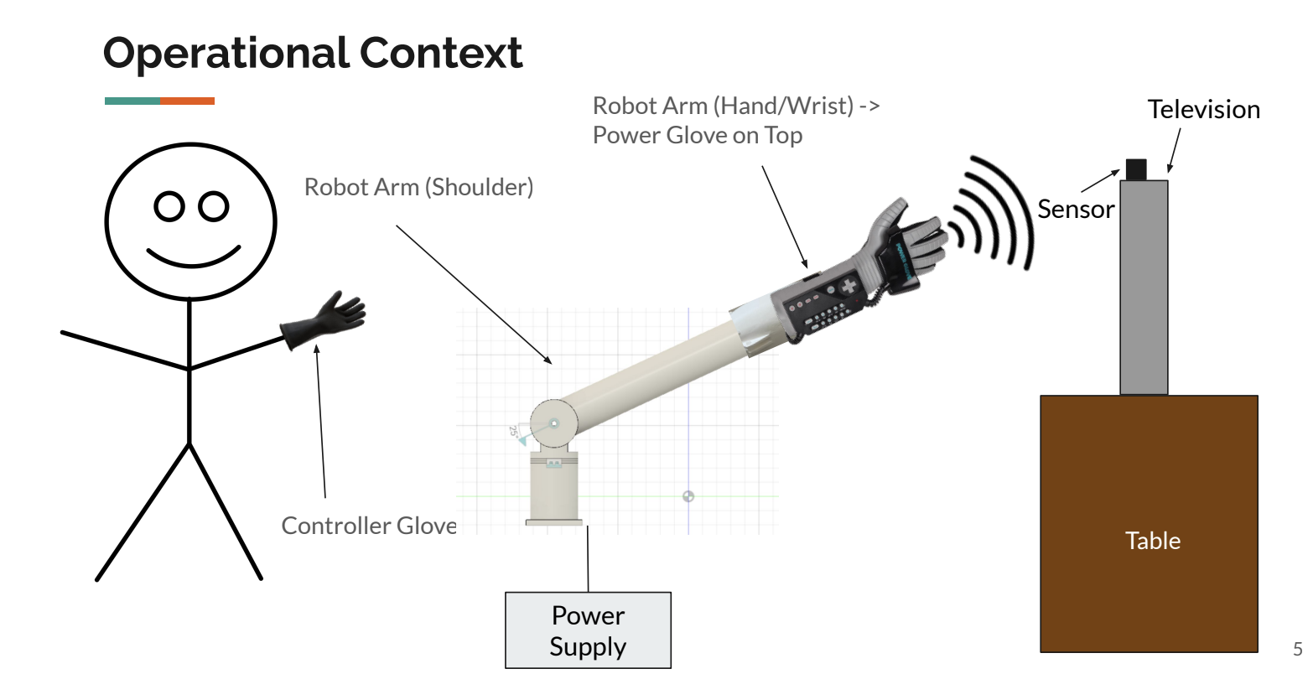

Figure 1: Context diagram

**3.2 Detailed Description**

**3.2.1 Fingers**

The fingers must each be capable of curling fully, with the ring, middle, and index finger curling at 3 joints and the thumb at 2. The NES Power Glove does not have any inputs for the pinky, as a result this pinky of this hand will not be curled with a servo motor, though it is fully articulated with pin connections to allow for slight curling due to the bending of the glove caused by the other fingers.

The finger part files come from InMoov [7], an open source humanoid robotics project, which is the same finger stereolithography files as used by last year’s ECD416 project. Each of the 4 fingers consists of 6 parts, with 2 parts that will be glued together to form each of the 3 members of the finger. The thumb, however, will consist of 4 parts, 2 for each of the 2 members of the thumb. The thumb .stl file also contains parts that fit into the full InMoov hand which is more articulate and complex than is needed for the NES Power Glove, so it is not the palm used in this design and those 2 parts will not be used. The stereolithography file for the index finger is depicted in Figure 2, with a CAD recreation of the final finger assembly shown in Figure 3 . Figure 4 shows the printed result of the index finger from last year’s project, though the very top half of the top member is missing in order to better fit in the glove, which will also be done for this project.

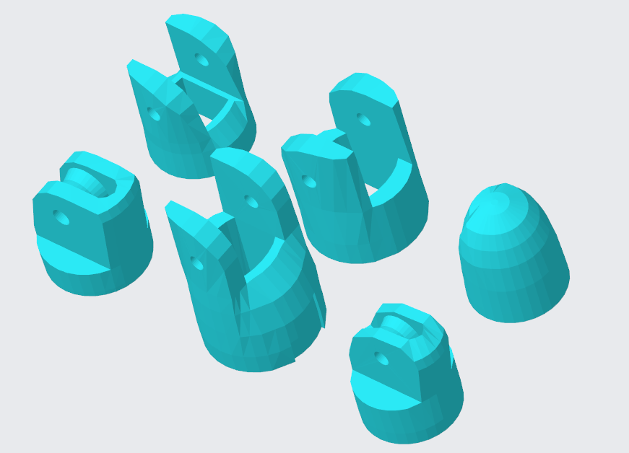

Figure 2: Index finger .stl files from InMoov.

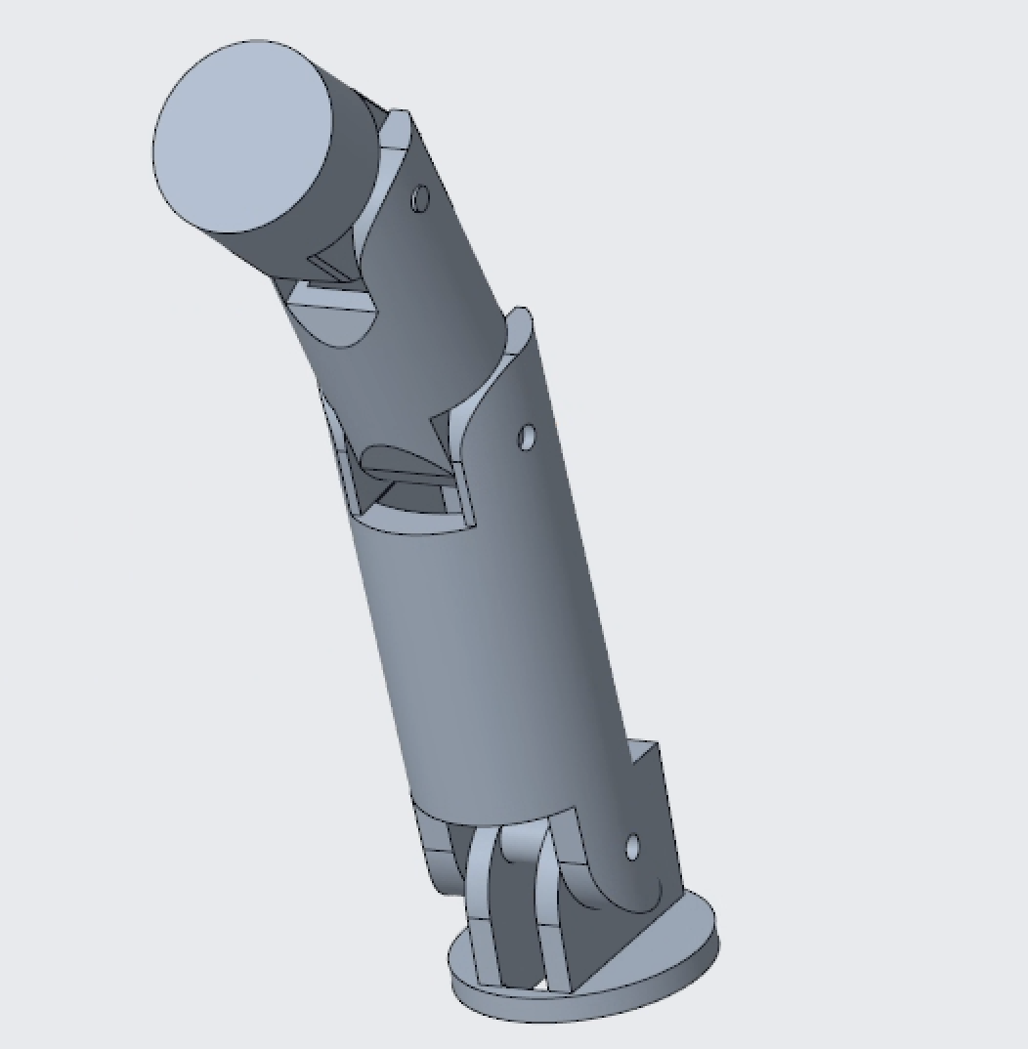

Figure 3: CAD recreation of assembled index finger on its hinge.

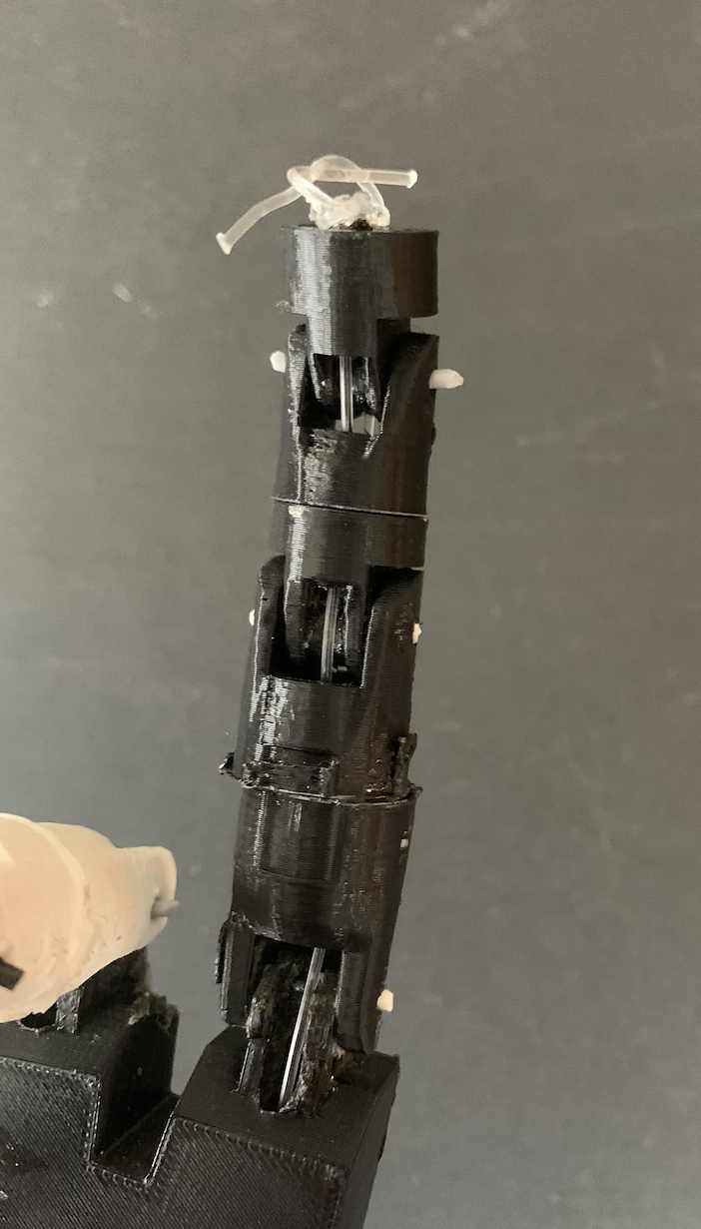

Figure 4: 3D printed index finger.

In order to achieve the curling and extending as required, 2 fishing lines are run from the tips of the fingers, through the hollow fingers and hand, and into the circular horns of the 12 kg servos in the forearm, which are discussed in further detail in Section 3.2.3. Figure 5 shows the interior of the hollow fingers, where the top fishing line in red pulls the finger to extend due to a counterclockwise moment, and the bottom line, when pulled, causes a clockwise moment that curls the fingers into a fist. The guides shown in Figure 5 allow the lines to stay on track and not interfere with each other.

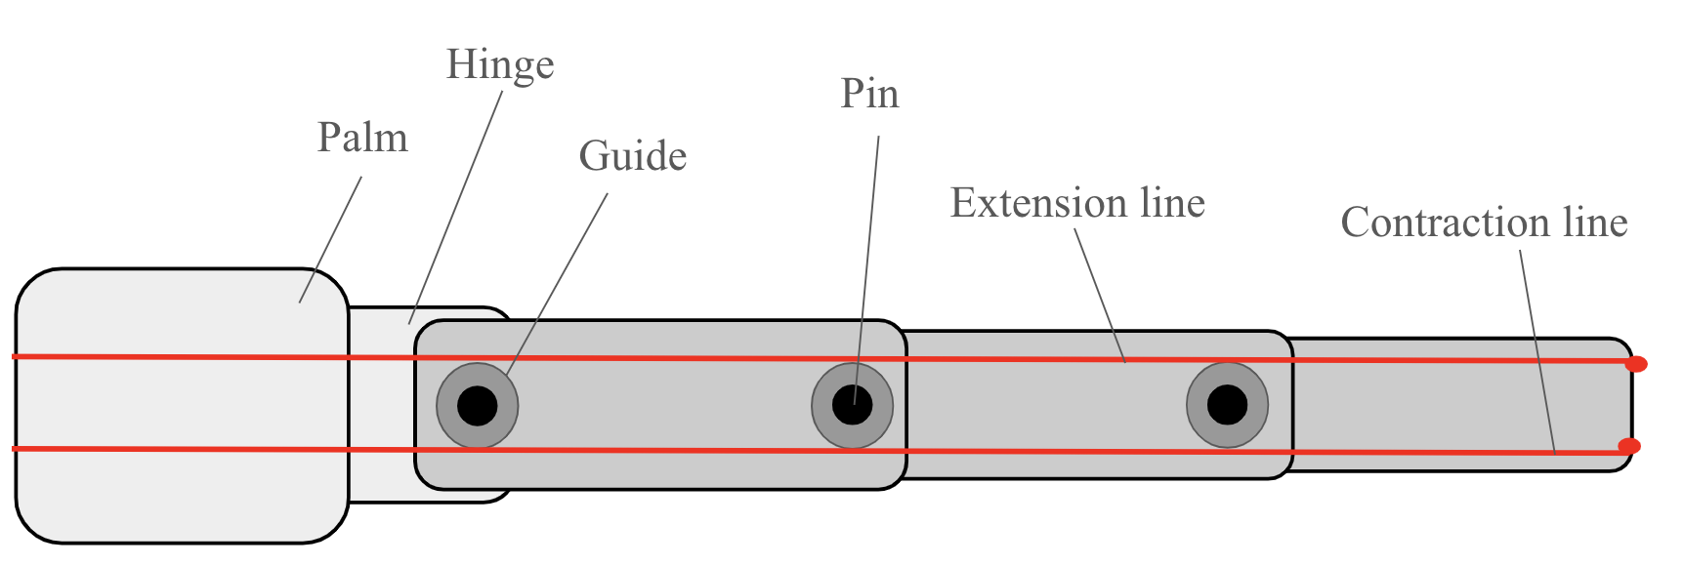

Figure 5: Diagram of interior of finger.

The line required must be strong enough to withstand the relatively light tensile load applied to it from the servos, which almost all fishing lines can withstand. Even if the servo were to malfunction and continue pulling on the line, the maximum force it can exert is 17.14 kg-force or 37.8 lbf or 168.1 N, though the actual load is significantly lower. Previously, a monofilament line was used which allowed for stretch and retained its shape when bent, both of which could potentially cause issues in controlling the extension and contraction of the fingers. This design switches to a braided fishing line, the SpiderWire Stealth Braid fishing line, which does not have shape memory when bent and does not stretch, which allows for greater translation of force from the servo to the fingers and thus more accurate control. It also has a 50 lb break strength and a 0.35 mm diameter, both of which are well within the desired values for this design.

Last year’s design used 12 kg servo motors for the fingers and this design will use 12 kg servos as well because through visual analysis the fingers performed correctly under these servos. However, to verify this, calculations were done as shown in Equation (1) to determine the angular acceleration of the middle finger when pulled by the 12 kg servo. A free body diagram of a simplified middle finger is shown below in Figure 6, where the 2 torques acting on the finger are from the servo and the weight of the finger, and the rotational moment of inertia about the hinge at the end is found using the mass and length of the finger. The mass of the finger is 0.0172 kg and the length is 234.4 mm.

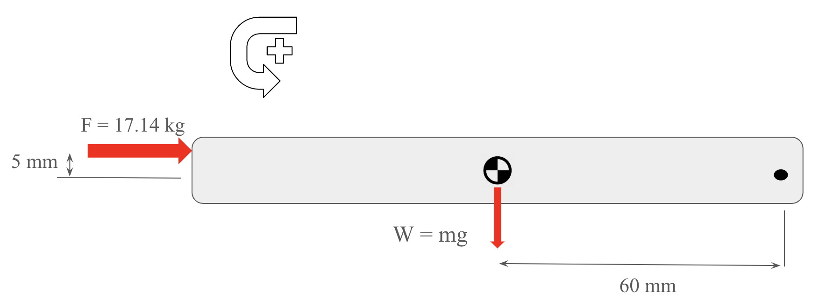

Figure 6: FBD of simplified middle finger.

|  | $Στ=(\frac{1}{3}⋅m⋅L^{2})α$ | (1) |
| --- | --- | --- |

$-(17.14 kg⋅m/s^{2})(.005m)+(0.168 kg⋅m/s^{2})(0.06m)=(-0.000315kg⋅m{}^{2})α$

$α= 240.1 rad/s^{2}$

The 4 12 kg servos in the forearm will be able to move the fingers at a sufficient speed if the angular acceleration is 240.1 rad/s2, though the fingers will curl much before the servo maximum stall torque is reached, so 240.1 rad/s2 is much more than these fingers will actually experience,

The material chosen for the finger is the same as the rest of the 3D printed parts of the arm, which is carbon fiber reinforced polycarbonate filament, or PC-CF. This material is stronger than the previously used ABS filament, with the PC-CF having a yield strength of 115 MPa [3] and ABS with a yield strength of 48.3 MPa [6]. This strength difference is not crucial to the fingers themselves, as the members of the fingers do not experience any significant load. This strength is more important when looking to 3D print the pins which will pin connect each joint, which is faster if printed out of the same material as the rest of the fingers. Figure 7 shows the top-most finger pin from the previous year’s index finger, which shows significant deformation from regular use.

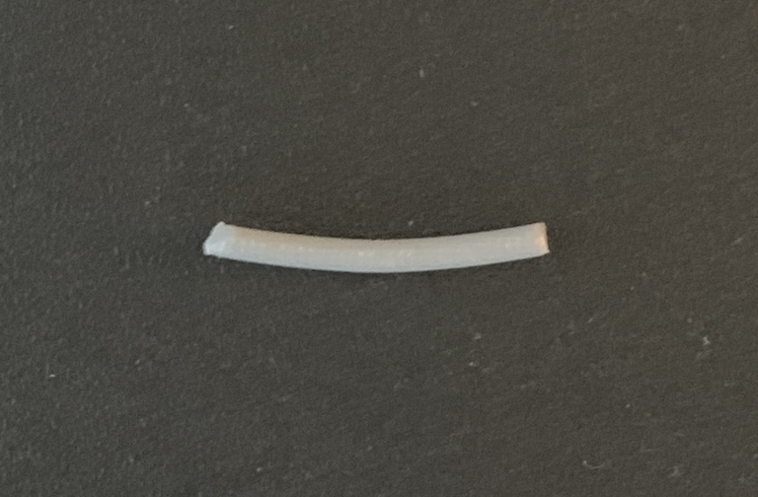

Figure 7: Previous ABS finger pin.

Finite element analysis was conducted on the finger pin made of PC-CF under the maximum load of 17.14 kg-force or 168.1 N in order to ensure that the deformation would be insignificant. The force was distributed over the center as if the upper member of the finger was being pulled at maximum force, which provides a large factor of safety. The sides of the pin are modeled as fixed supports to imitate the support of the lower finger member. Figure 8 below shows the deformation plot, with a maximum displacement of 0.054 mm, even under maximum load. This displacement is small enough that it will not affect the control of the fingers.

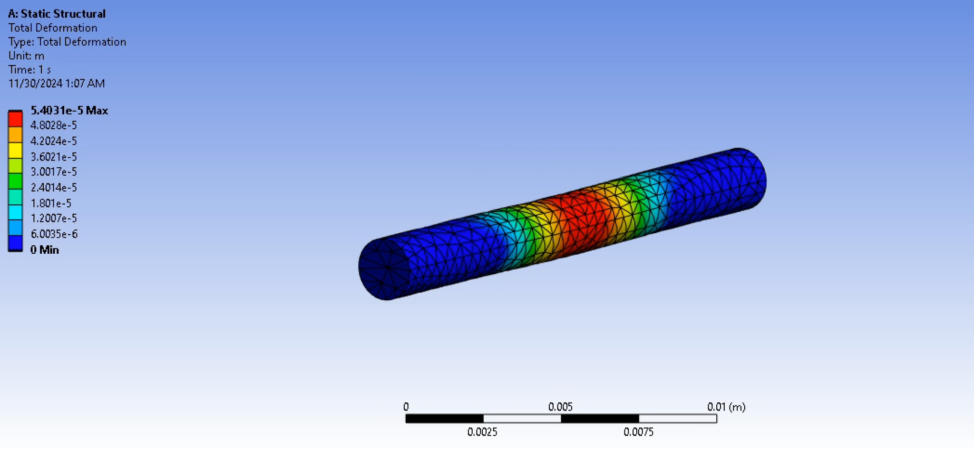

Figure 8: Deformation plot of PC-CF finger pin.

The fingers will attach to the palm through a pin connection, same as the joints of the rest of the finger. The hinges were made to the same dimensions as the current hinges that are built into the InMoov hand in order to ensure they fit with the InMoov fingers. Because the hand design is dependent on the angle at which the fingers are placed on top of the palm, the hinges are modeled with a 21 mm diameter circle with a height of 2 mm, so that when being glued onto the palm, they can be rotated to fine tune the angle before the glue dries. The hand is discussed in further detail in Section 3.2.2. The base circle and the hinge itself have a gap to allow the fishing line to pass through from the palm into the fingers. Figure 9 shows the CAD model of the hinge for the index finger. All hinges are similar in shape with slight differences in dimensions, which can be seen in the detail drawings in Appendix C.

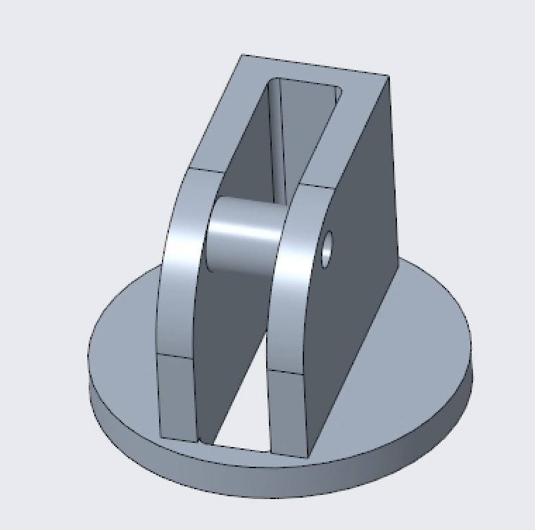

Figure 9: Index finger hinge.

**3.2.2 Hand**

The hand portion featured one of the most important design alterations from last year’s model. A main issue the team encountered when working with the existing arm was that the palm was flat and the fingers were fully spread out. This made putting the Power Glove on and removing the glove quite difficult. As such, we began considering ways to alleviate this issue. The finalized solution was to make the palm curve in a concave fashion, creating a 60 degree arc. This way, when the fingers curl inwards, they do so in a manner that makes it easier to pull the glove on and off the arm.

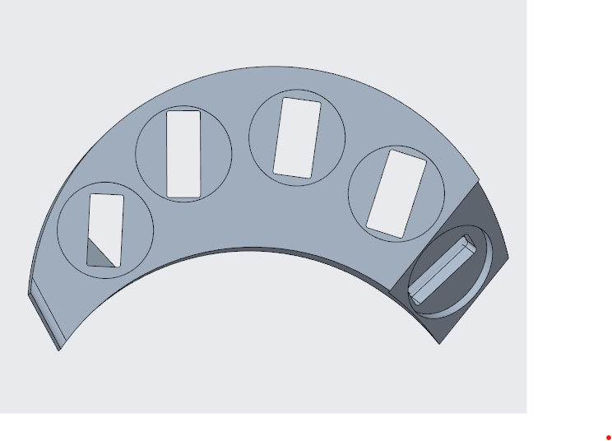

Figure 10: Hand Part Top View

This top view displays the arched nature of the palm and how it is more compatible with the power glove. It allows the fingers to exist in a more clasped position, narrowing the distance between ends of the hand whilst maintaining enough space for all fingers and corresponding hinges. Beyond this, the bottom of the hand was shelled out to be hollow, a logical implementation considering we will need wires and fishing lines to run up from the shoulder to the fingers. However, an extra component was needed to connect the hand to the wrist/forearm piece. Intuitively, it’d make sense to screw the bottom of the hand to the topmost part of the wrist. However, since it needs to be hollow, the team decided to implement a pole-type piece that connects to the top part of the hand and extends down, protruding from the bottom. This pole fits exactly with a hole atop the wrist cover, allowing it to go directly into the wrist piece. From underneath the wrist cover (as will be further explained in the following section), a gear will be placed on the portion of the pole protruding through the wrist cover. This will be part of the mechanism that allows the wrist to twist and turn as needed while also securing the hand and fingers to the rest of the arm.

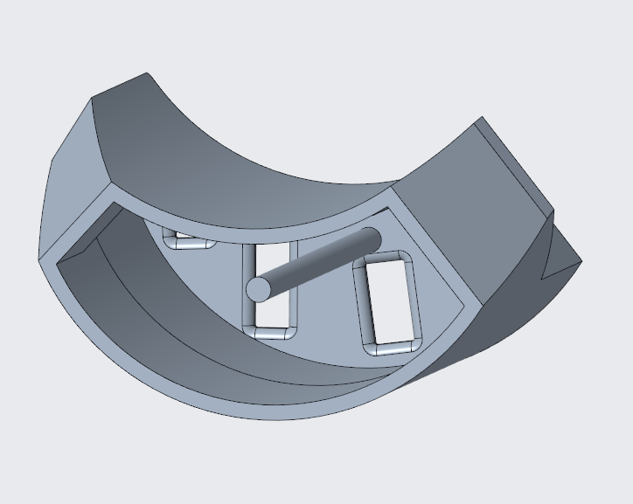

Figure 11: Bottom View of Hand

The hand will be made of the same material, Polycarbonate Carbon Fiber (PC-CF) as the rest of the arm. PCCF is an outstanding material for 3D printing robotic arm components due to its combination of strength, lightweight properties, stiffness, impact resistance, and ease of printing, an especially important aspect given that we have free access to 3D printing at Binghamton University. The main part stands at 88.9 millimeters with the pole extrusion adding an extra 9.1 mm to the total height. The total width is 87.87 millimeters. The finger holes each have matching diameters of 20 millimeters. The remaining dimensions will be displayed in the part drawing in Appendix C.

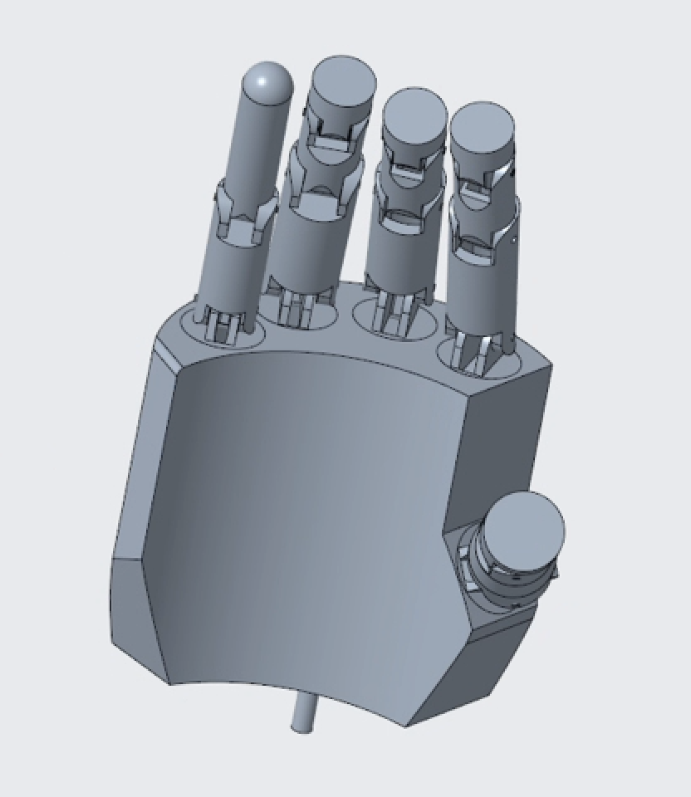

Figure 12: Standard View of Hand

**3.2.3 Wrist/Forearm Subsection**

In order to satisfy the requirements regarding wrist rotation and finger movement, it was decided that 12kg/cm servos are sufficient in fulfilling the previously mentioned requirements. The purpose of the Wrist/Arm subsection is to house all the components required for wrist rotation as well as finger movement.

Throughout this project, three different materials were considered for the construction of the Wrist/Arm. The first consideration was 304 stainless steel. Overall 304 stainless steel is cheap and durable, however using it would require a manufacturing process outside of Binghamton University. Additionally 304 stainless steel is conductive, which is something to consider since there are electronic components housed in the design. The next material consideration was aluminium 6061. Aluminium 6061 is cheaper than 304 stainless steel while also being slightly less durable, and more expensive to manufacture than the stainless steel counterpart. Again, the aluminium 6061 material is conductive, more so than the 304 stainless steel. The final material for consideration and the material that was ultimately chosen was carbon fiber composite filament.

Each part in the wrist/arm subsection will be 3D printed to a length of 265.5 mm with a wrist radius of 30 mm, an arm radius of 35 mm, and a base radius of 45 mm. The base of the wrist part has six holes that are compatible with M3 screws that connect the writs/arm subsection to the shoulder. There are a total of 26 holes that are compatible with M3 brass inserts, that allow the other sections of the wrist/arm subsection, as well as the servos connect to the wrist part. The servo responsible for hand rotation connects to the hand subsection with a 4 to 1 gear ratio, allowing the hand to rotate 90 degrees in either direction. Underneath each section that houses a servo in the wrist, is a channel that allows for wires to be fed through the device, allowing them to be concealed and organized.

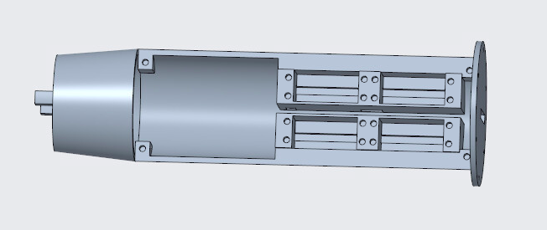

Figure 13: Wrist

At the top of the wrist part, there is a hole that is 24 mm wide with a width of 2 mm that allows a set of two braided fishing line that connects from each of the servos in base of the arm, to its corresponding finger.

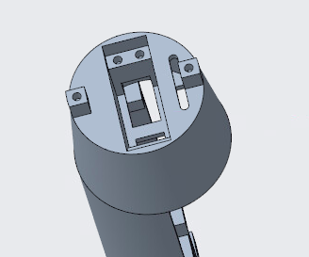

Figure 14: Top of Wrist

The wrist cover part has two holes at the top that are compatible with M3 screws, and connect the wrist cover part to the top of the wrist part. There are two channels with a width of 8 mm underneath the two holes that secure the connection between the wrist cover and the wrist. The outer radius of the wrist cover is 30 mm, with an internal radius of 25 mm. There is a center hole with a radius of 2.5 mm, that connects the hand to the rest of the wrist/arm subsection. There is a hole at the top of the wrist cover that has the same dimensions as the hole on the top of the wrist, 24 mm wide with a width of 2 mm.

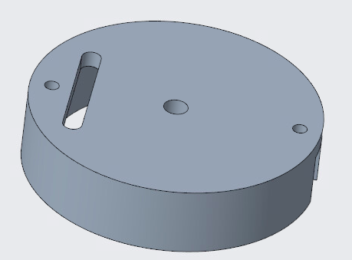

Figure 15: Wrist Cover Top

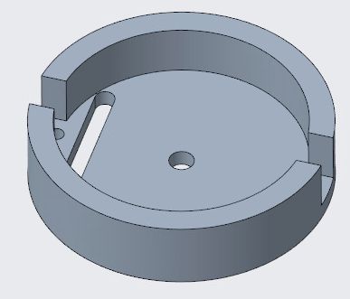

Figure 16: Wrist Cover Bottom

The back cover is designed to cover the servos and the fishing lines located in the wrist part. The back cover has four holes that accept M3 screws that connect the back cover to the wrist, via the M3 brass inserts in the wrist. The back cover has a length of 210 mm, which is the same length as the section of the wrist part that contains the fishing lines and the four finger servos.

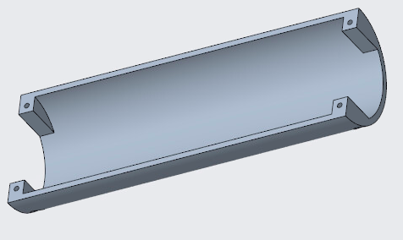

Figure 17: Back Cover

**3.2.4 Shoulder (Pitch)**

As discussed in Section 3.2.3, the base of the wrist part screws into the rotating part of the shoulder that is responsible for the pitch of the shoulder, which must be able to rotate the arm back and forth in a range of 90° from horizontal to vertical. 6 M3 brass insert will be melted into 6 holes located on the rotating pitch part, as shown below in Figure 18.

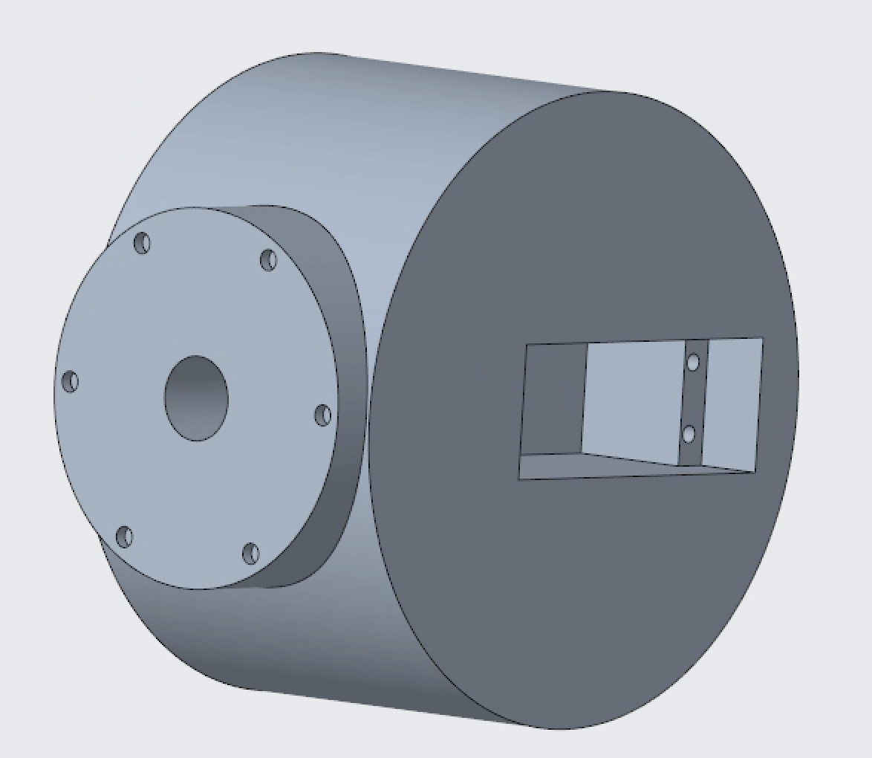

Figure 18: Rotating part of shoulder for pitch.

This part and thus the arm rotate due to the torque of the 60 kg servo motor mounted with 2 M3 screws fastened into 2 M3 brass inserts melted into the 2 holes in the rectangular cutout for the servo rotating piece. The cutout for the servo is dimensioned in such a way that the rotating head of the servo is in the very center axle of the rotating shoulder part. This fit between the servo and rotating part is depicted in Figure 19.

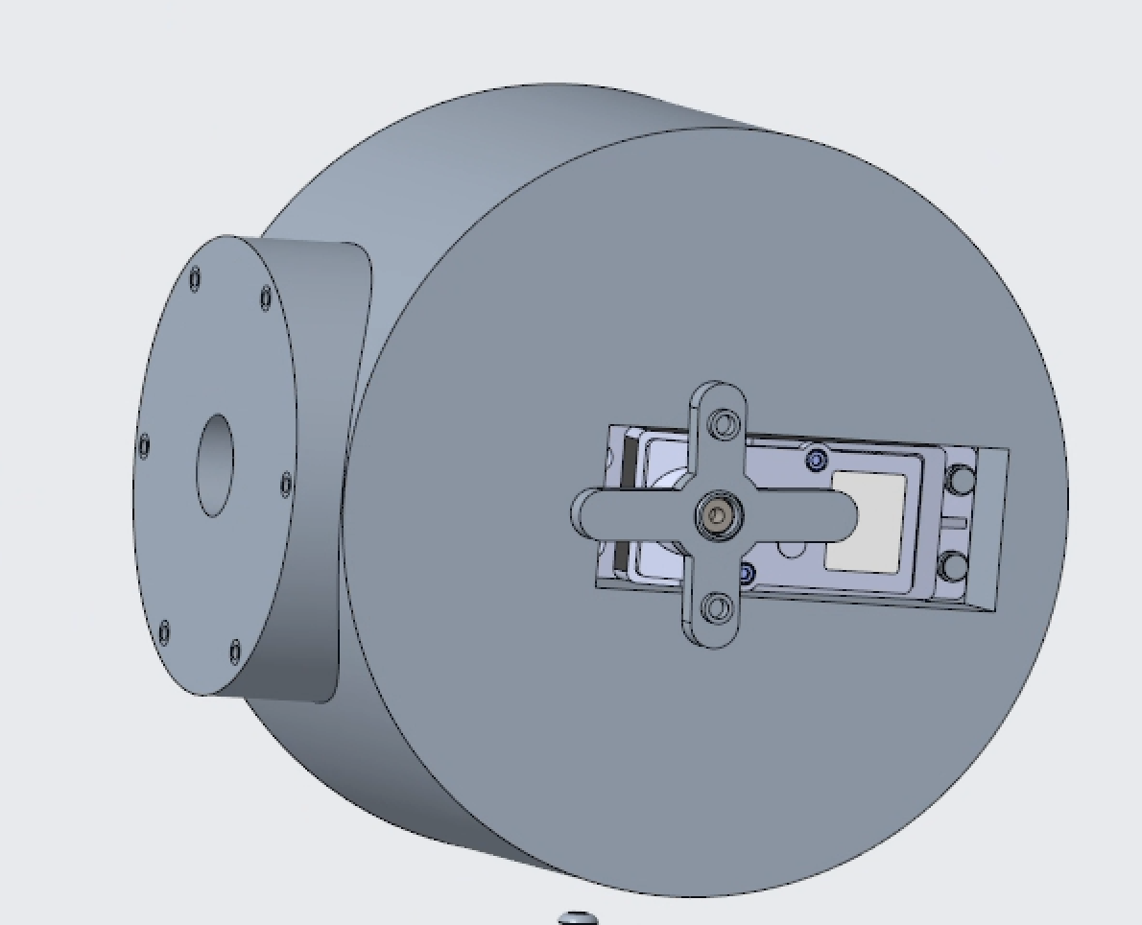

Figure 19: Servo in Rotating part of shoulder

The previous rendition of this arm used a 60 kg servo, as will this design. Similar to the finger in Section 3.2.1, the dynamics of the arm were calculated to determine if the strength of the servo allows for reasonable angular acceleration, the FBD for this calculation can be seen in Figure 20.

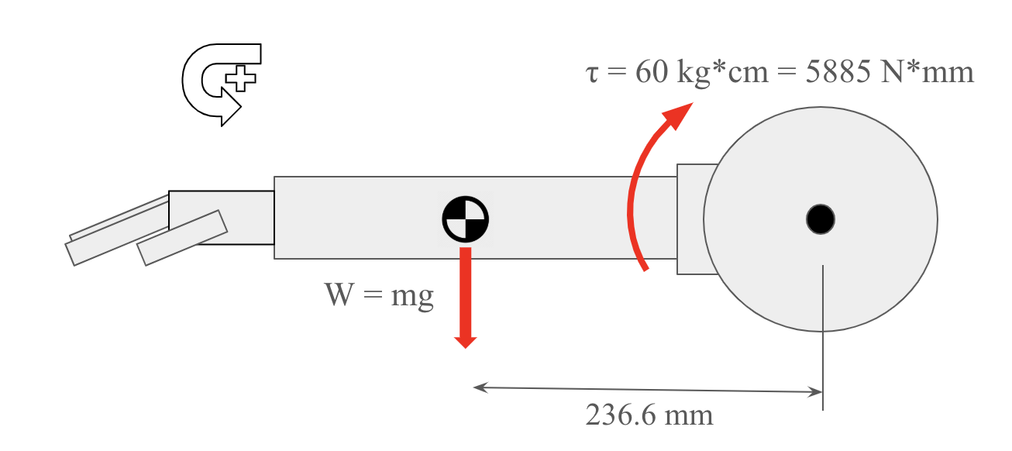

Figure 20: FBD of arm and rotary shoulder part.

As determined by Creo Parametric, the mass of the arm (5 12 kg servos included) is 1.91 kg. These values, along with distances, can be used to determine the angular acceleration of the arm as shown in Equation 1.

|  | $Στ=(\frac{1}{3}⋅m⋅L^{2})α$ | (1) |
| --- | --- | --- |

$(18.74kg⋅m/s^{2})(0.2366m)-(5.884kg⋅m/s^{2})=(-0.134kg⋅m^{2})α$

$α= 10.8 rad/s^{2}$

An angular acceleration of 10.8 rad/s2 will be sufficient to track the user’s arm pitch movements.

The cross-shaped horn that fastens the servo in the rotational piece to the stationary shoulder piece is made of ABS plastic and comes with the servo package. This will be fastened to the stationary shoulder piece using M4x20 screws into M4 brass inserts in the servo horn, so that when the servo spins, the rotational piece it is built into spins as well. This portion of the assembled shoulder can be seen in Figure 21 and the exploded fit between the parts can be seen in the shoulder subassembly drawing in Appendix C.

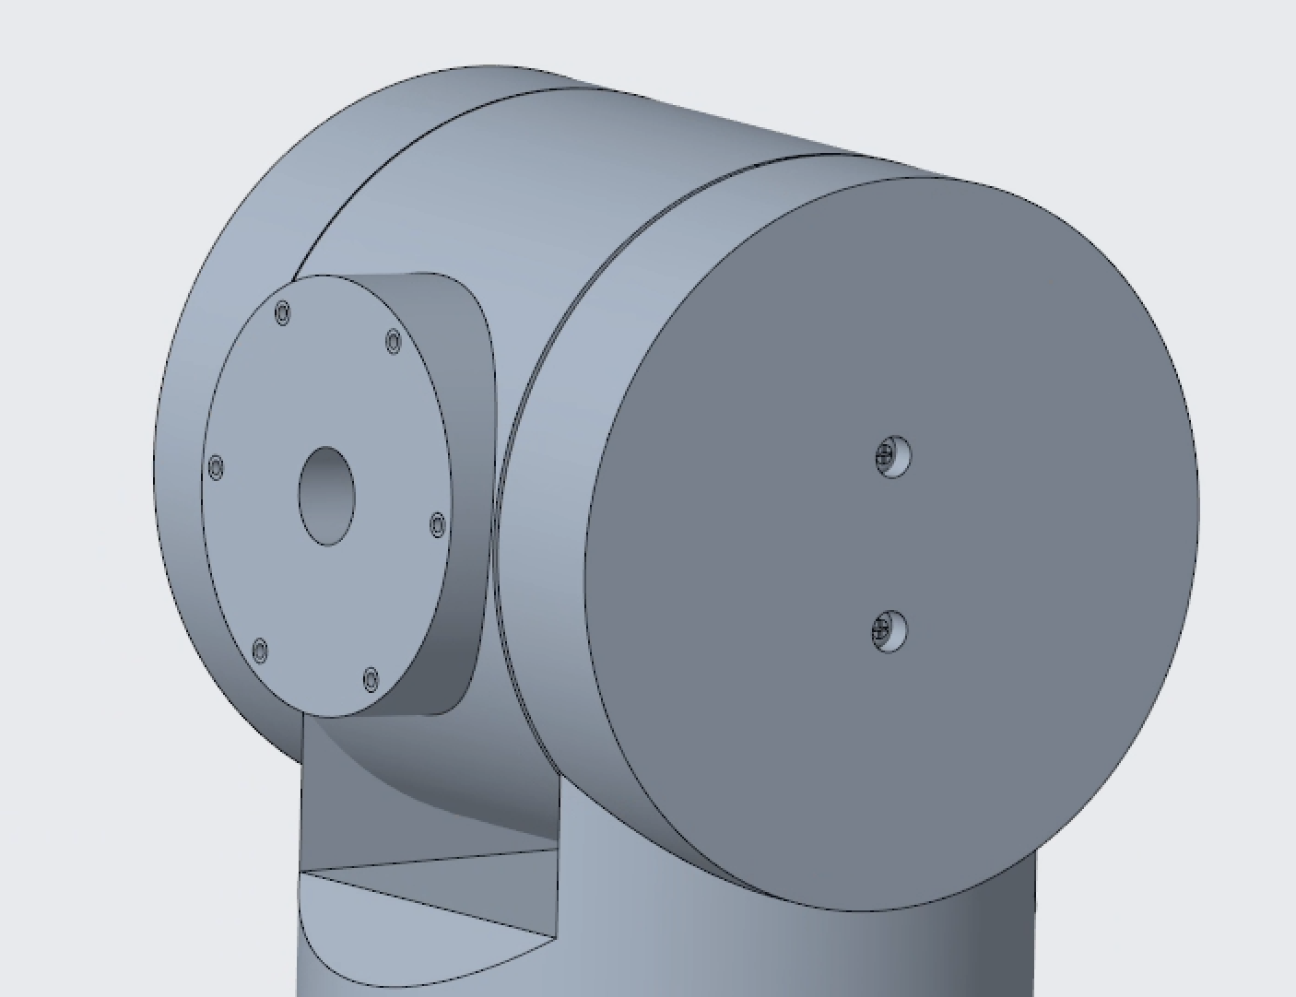

Figure 21: Pitch shoulder connection.

This servo horn was analyzed using FEA in order to ensure that the hard stops of the pitch servo would not cause significant deformation or stress on the horn, which could in turn cause jerkiness and unresponsiveness.

Equation 2 as shown below uses the pitch angular acceleration determined previously in order to find the tangential acceleration at the center of gravity, which is located *d* meters from the pitch servo axis of rotation. Equation 3 then uses that tangential acceleration to find the tangential force as the arm is in a horizontal position.

|  | $a=\frac{α}{r}$ | (2) |
| --- | --- | --- |
|  | $a=\frac{10.8 rad/s}{0.2366 m}=45.64m/s^{2}$ |  |
|  | $F=ma$ | (3) |
|  | $F=(1.91kg)*(45.64m/s^{2})=87.17N$ |  |

This force of 87.17 was divided in half and 43.6 N were applied to each of the 2 holes on the horn where the M4x20 screws will be inserted, as indicated by the red markers in Figure 22. The blue marker in the figure indicates a fixed support where the horn is attached to the servo head.

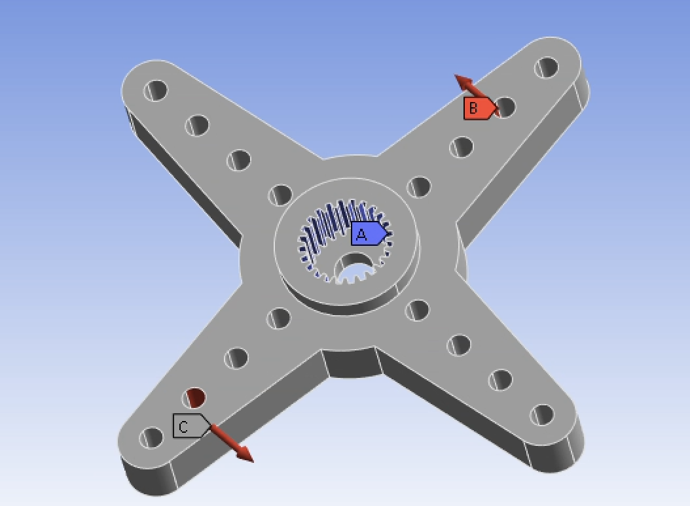

Figure 22: 60kg servo horn boundary conditions.

This deformation plot of this analysis is shown below in Figure 23, where the maximum deformation is 0.13 mm as seen by Figure 24 and it occurs at the very tips of the horn.

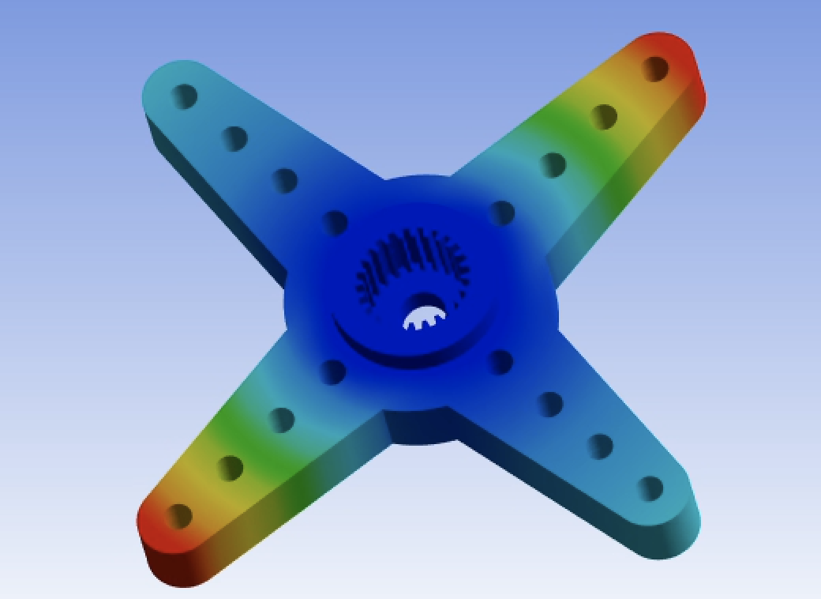

Figure 23: 60kg servo horn deformation plot.

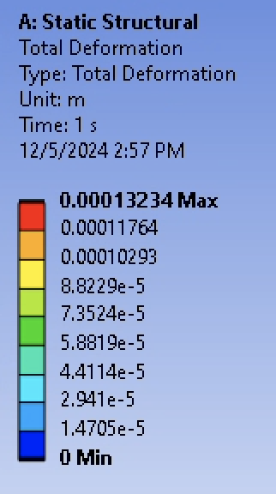

Figure 24: 60kg servo horn deformation values.

Additionally, the equivalent stress was also solved for, which can be seen in the stress plot (Figure 25) and the stress values (Figure 26). The maximum equivalent stress is 8.3 MPa, occurring at the interior of the teeth where the horn connects with the servo head.

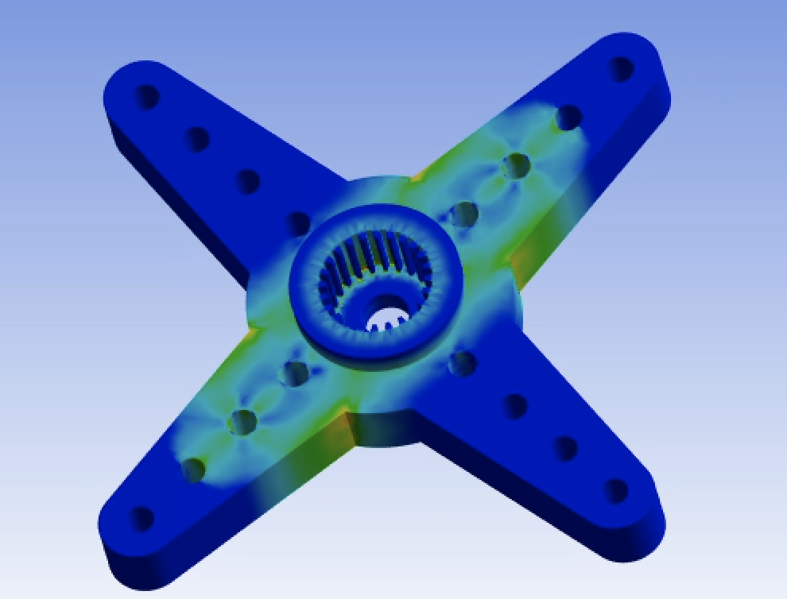

Figure 25: 60kg servo horn equivalent stress plot.

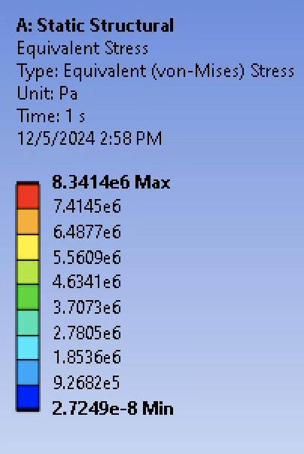

Figure 26: 60kg servo horn equivalent stress values.

The yield strength of ABS plastic is 32 MPa, meaning this horn has a factor of safety of 3.9.

One of the stretch goals of this design was to hide wires from the front of the device as opposed to the loose wires of last year’s design. In order to achieve this, a hole 20 mm in diameter is located in the center of the shoulder-wrist connection face, allowing the 5 wires to run from the inside of the forearm into the shoulder. This wire channel runs to the 60 kg servo cutout and exits out of the center axis of rotation on the side opposite the servo, as shown in Figure 27. This hole in the center of the circle also allows the 60 kg pitch servo to run its wire out of the rotational piece.

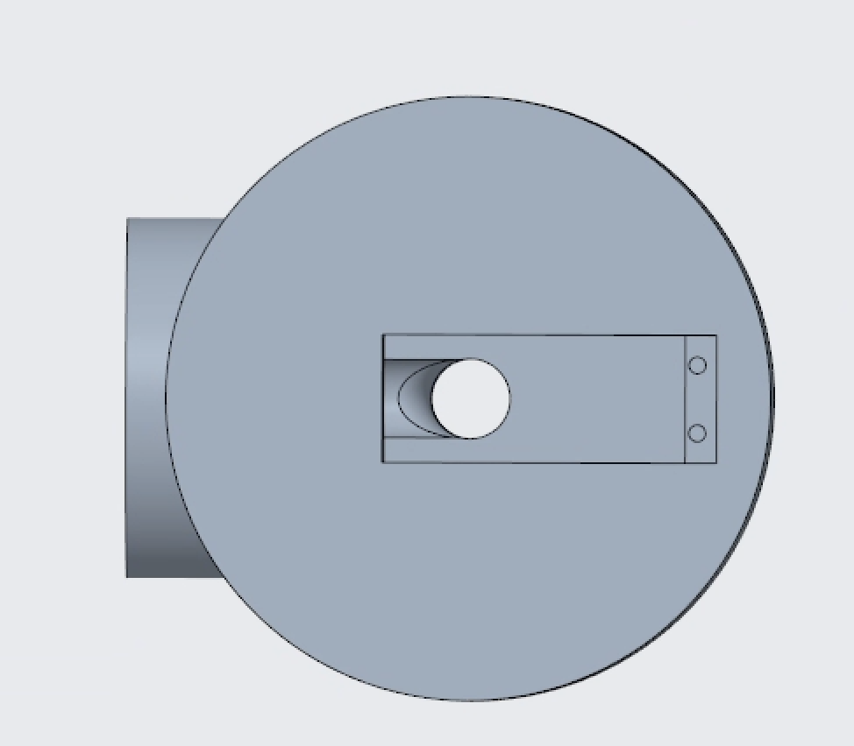

Figure 27: Servo wire channel.

Because the wire will be moving in between the rotational and stationary shoulder parts, it must be a high flex wire commonly used in robotics for this purpose. The wire, which can be seen in the finance table in Section 5.2, is 20 AWD high flex copper wire with silicone sheathing in order to allow for high degrees of movement. This wire will be soldered to each servo inside the rotational piece of the shoulder, where the non-flexible servo wire will be stationary in relation to its surroundings. The high flex wire will then run into the stationary piece as is further described in Section 3.2.5.

**3.2.5 Shoulder (Yaw)**

The stationary pitch part, as just described in section 3.2.4, is actually the rotational part of the yaw mechanism, which functions in a manner similar to the pitch. This rotational yaw part, as seen in Figure 28, has 2 holes in the base for 2 M4x20 screws to fasten it to the 60kg yaw servo underneath it.

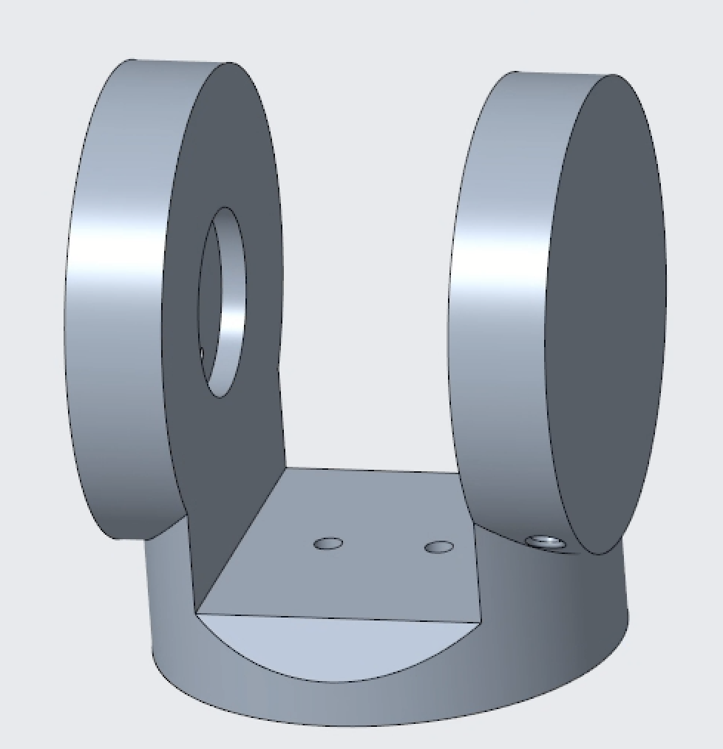

Figure 28: Rotational yaw part/stationary pitch part.

The decision to once again go with the 60kg servo is based on the calculations done for the 60kg pitch servo in section 3.2.4. The main part of the arm (forearm and hand) still has the same moment of inertia about its end, the only difference being there is no load creating a torque opposite the servo torque, like there was with the moment by gravity going against the raising of the arm by the pitch servo. This reasoning permits the use of a 60kg servo for the yaw.

This servo will be mounted in the shoulder base as seen in Figure 29, using 4 M3x6 screws. The servo mount is positioned in such a way that the servo head pin is in line with the center axis of the base, making sure it lines up with the rotational yaw part.

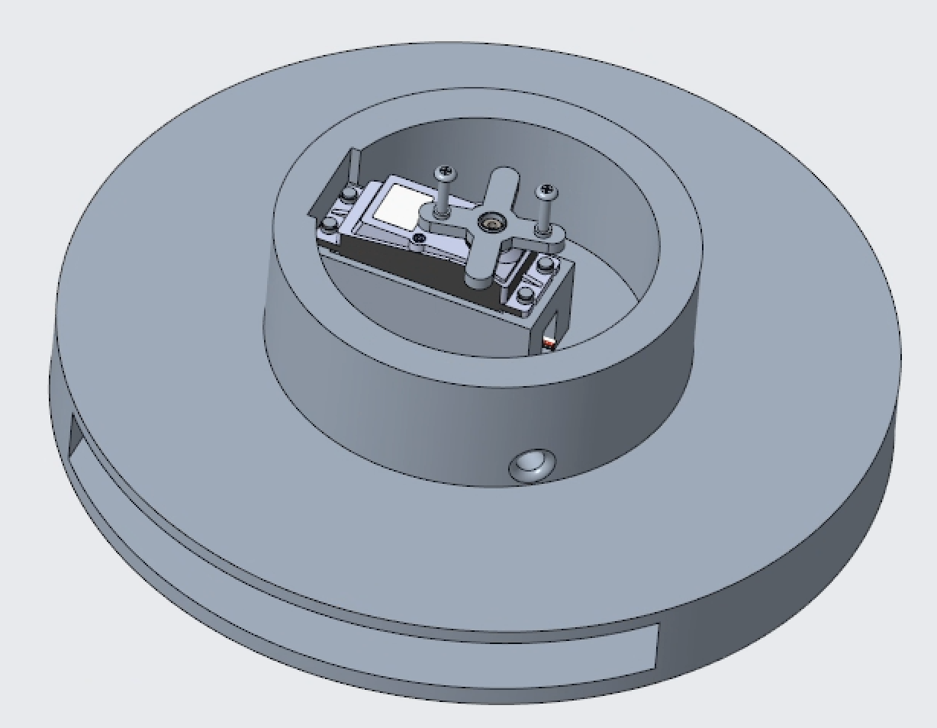

Figure 29: Shoulder base with 60kg yaw servo mounted.

The slot cut out in the very bottom of the base, as seen in Figure 29, is to house the 4.5 kg weight. This weight is used to reduce any instability in the base that could lead to instability in the arm itself and thus cause issues with jerkiness and control. Because the previous year’s design only had minor wobbling, it was estimated that a 4.5 kg weight will be sufficient in reducing wobbling. This will be tested in the spring semester, as the weight is a standard part and should a heavier weight be required for unforeseen reasons, it can be added with minimal changes to the overall design.

As mentioned in section 3.2.4, hiding the wiring better than last year’s design was a stretch goal of this design, so the shoulder pitch part solved this by running the pitch, wrist, and finger servo wires inside the rotational pitch part. This wire will run into the rotational yaw part through the hole in the rotational axis as shown in Figure 30.

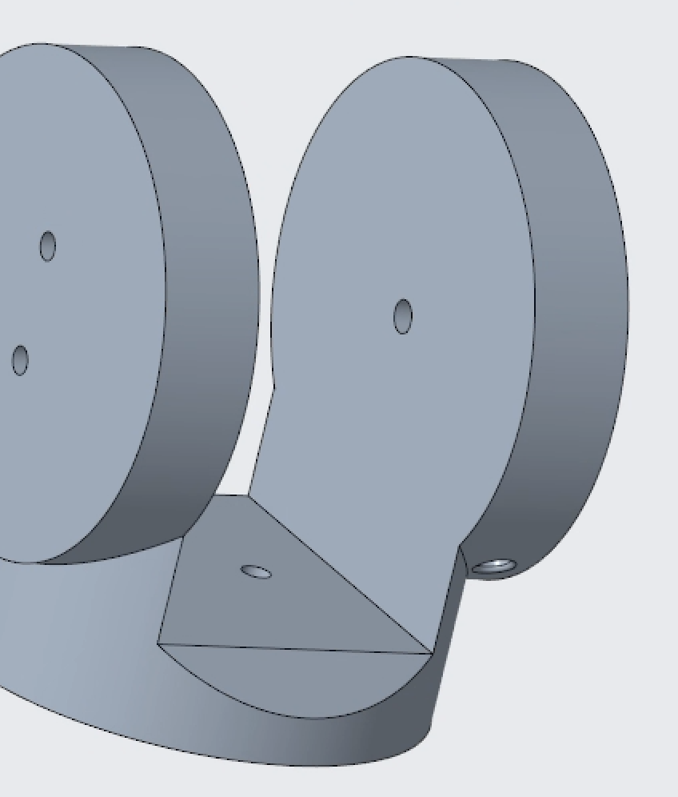

Figure 30: Wire channel holes for high flex wire in rotational yaw piece.

The 20 AWG high flex robotics wire will then run out of the back hole shown in Figure 30, with enough slack that the 90° rotations of both the pitch and yaw do not pull the wire from its connections in the ESP32 located on the back of the shoulder base. This overall wire management diagram for the shoulder can be seen in Figure 31.

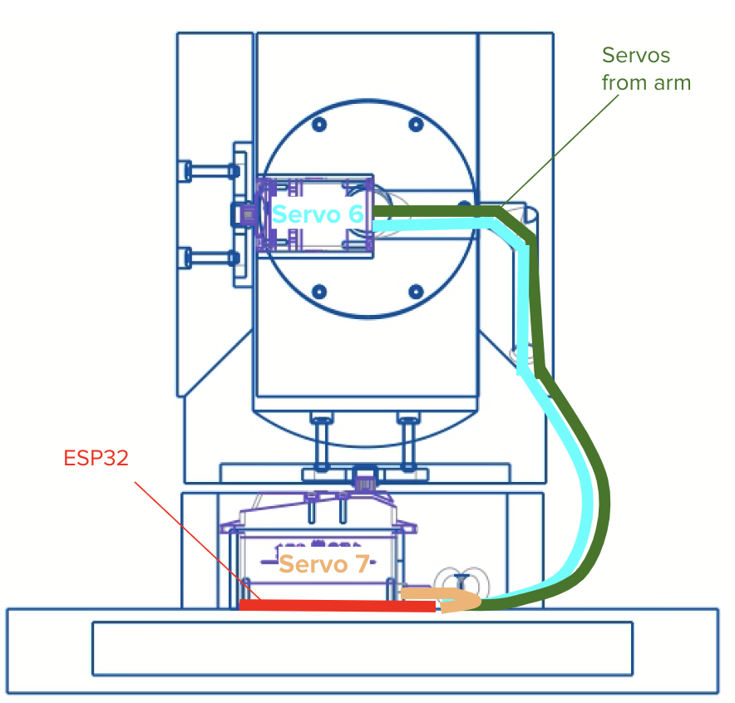

Figure 31: Wiring diagram for shoulder.

Both Figures 29 and 31 show the wiring for the yaw servo just runs out of a hole in the base wall and into the ESP32. This wire is stationary and thus does not need to be high flex wire.

**3.2.6 Electrical**

The electronic components of this project include an ESP32, five 12kg/cm servos, and 2 60 kg/cm servos. The entire system is powered by a 12 volt power supply, with the voltage to each of the electronic components.

The signal connections on each of the servos are connected to a particular terminal on the ESP32. For the five 12kg/cm servos that control wrist and finger movement, the wrist control is connected to GPIO19, thumb control is connected to GPIO2, the pointer finger control is connected to GPIO4, the middle finger control is connected to GPIO5, and the ring finger control is connected to GPIO18. For the two 60kg/cm servos that control the shoulder movement, pitch control is connected to GPIO21, and yaw control is connected to GPIO22.

To manage the wiring complexity and ensure reliable signal and power delivery, a custom PCB was designed, fabricated, and integrated into the robotic arm system. The PCB connects the ESP32 microcontroller to all servos, consolidating the control and power circuitry into a compact layout. Key feature of the PCB is headers for servo signal and power linesn. The board was fabricated using standard FR4 substrate and assembled in-house using surface mount and through-hole components. Its compact size allowed for easy mounting within the shoulder housing. The PCB is mounted within the shoulder section withr the ESP32 to minimize wiring length and reduce EMI.

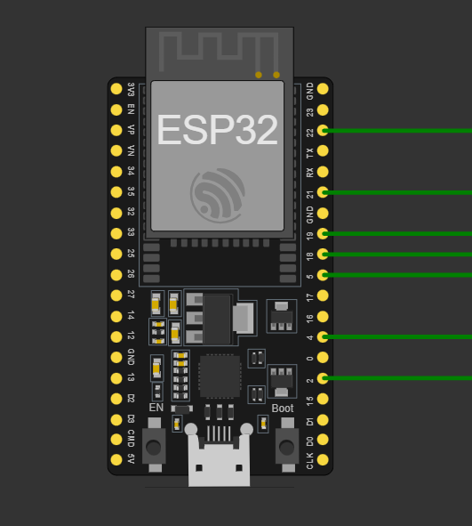

Figure 32: ESP32 servo signal connections.

**3.2.7 Code**

The primary objective of the code is to control the robotic arm, the code serves as a means and enables precise and responsive movements which are based on the hand movements of the user. It facilitates communication between the servo motors and the microcontroller chip controlling various parts of the arm including fingers, wrist and shoulders (enables yaw and pitch).

The code achieves the mentioned functions by:

1. Receiving input data: The ESP32 receives positional data from the glove, which is equipped with sensors like the MPU6050 for accelerometer and gyroscope measurements and flex sensors for finger movement tracking. The data is transmitted wirelessly through Bluetooth.

2. Processing Data: the received data is parsed to extract specific positions for each servo, which represents the desired state of the robotic arm.

3. Controls the servo motors: the data that is received is parsed and mapped to various angles of the servo motors , which enables the robotic arm to mimic the user hand movements.

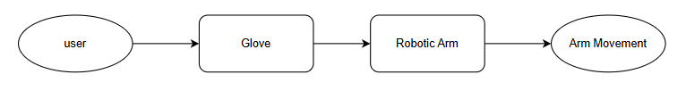

Figure 33: Data Flow Diagram: Split into the Glove and Arm

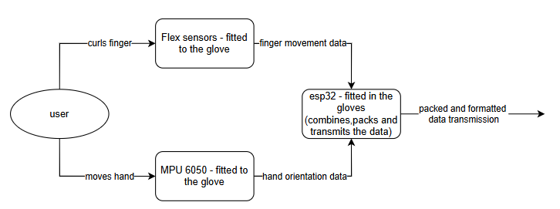

Figure 34: Data Flow Diagram: Glove

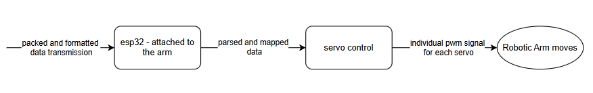

Figure 35: Data Flow Diagram: Arm

**Key Features:**

Servo motor control:

* The code enables precise control of multiple servo motors, each responsible for a specific part of the robotic arm, including fingers, wrist, and shoulder (pitch and yaw).
* Servo positions are dynamically updated based on input data, allowing smooth and responsive movements that accurately replicate user gestures.
* Includes logic to adjust specific servo positions

Bluetooth Communication:

* Uses SoftwareSerial to establish communication between the microcontroller and a Bluetooth module.
* Receives real-time data wirelessly from the glove sensors, ensuring a seamless connection between the user interface and the robotic arm.
* Efficiently handles incoming data, ensuring uninterrupted transmission and responsiveness.

**3.3 Use**

The purpose of this project is to create a robotic arm that wears a NES Power Glove, and has the capacity to use the glove to play NES games such as “Super Glove Ball”. The client Techworks! operates a museum. In one of its displays visitors to the museum can put on the glove and use it to play NES games. Techworks! was concerned that visitors that used the glove in their display would, over time, cause damage to it. So Techworks! requested the creation of this robotic arm that can be controlled by a museum visitor, allowing them to still try the NES games, while also keeping the NES Power Glove in good condition.

**4. Implementation**

The implementation phase involved the physical construction and integration of the necessary components to create our desired robotic arm design. Following an extensive design process, the goal was to follow our pre-decided plan. The majority of the project, the arm itself, would be 3D printed. This involved simply converting our already existing CAD files of each part (the fingers, the hand, the wrist, the forearm, and the shoulder) into stl files and submitting them to the ETS 3D printing services. Beyond this, a table of required parts was purchased while remaining within the allotted budget. This list can be seen in section 6.2. Once all parts were successfully printed/ordered, the actual implementation could begin. Work began on the shoulder to allow us to build from the bottom up. The shoulder featured a subassembly of its own, consisting of a pitch part and a yaw part, both of which rested atop a circular base piece with a 10 lb weight in it to stabilize it. The circular base piece had a 60 kg servo within it on its topmost surface which, when attached, allowed the yaw piece to rotate. After an initial attempt to attach these two pieces on just the bare servo, it became apparent this was not efficient. Due to the servo’s horns, an unstable gap was created between the two parts, which we quickly knew would lead to troubles. As such, we implemented ball bearings in the gap between to better distribute the weight of the yaw piece, which made for much more stable results. The yaw piece was screwed (M3 screws) into the servo horns of the servo. After this, the pitch piece was placed within the yaw piece. Responsible for the pitch motion of the arm, this piece required space for a second 60 kg servo, but placed vertically. This way, when connected properly, the spinning of the servo would correspond to an up and down motion of the arm. This piece was fastened successfully within the yaw piece using the same M3 screws to the second servo’s horns. It is important to note that brass fittings were used for all screw connections within the PLA plastic of the arm’s exterior. For the servos, they were drilled in. Beyond this, the forearm piece was now needed to be set up to be connected to the pitch piece of the shoulder. This connection was made with 6 screw holes that aligned with the bottom of the forearm piece and the circular flat surface of the pitch piece. Within the 4 designed compartments of the interior forearm, 4 servos were fastened in. Brass inserts were placed into the forearm piece using a heat gun to melt the inserts into place. This was done in all corners of the forearm, allowing for both the servos to be screwed in as well as the backplate to screw onto the forearm. But before the backplate could be screwed on, the braided fishing line needed to be strung from the fingers down through the wrist and fastened to each 12 kg servo. So, the hand subassembly was worked on simultaneously to the forearm. The fingers were easily fastened into the hand’s finger slots using glue and even melting them in with a heat gun. Filament pins were placed into the fingers to allow each joint to curl inwards and outwards around. These filament pieces were glued into each joint and cut to appear seamless. Braided fishing line was glued to the topmost part of each finger. Each finger yielded a pair of fishing lines, one responsible for curling the finger when pulled and the other responsible for restoring the finger to its original upright position. These pairs of fishing lines were run through the hand and wrist piece and down the forearm. The ends of each pair were fastened to each servo horn. This was done by tying them around the screws in each servo horn and gluing them down for extra security. They were knotted into the drilled holes of the servo horns as well. Now, the backpiece could be screwed into place, making the forearm a complete cylinder concealing the intricate inner workings. It is worth noting the ring finger and pinky finger fishing lines were fastened to the same servo, as the input of the pinky was not important in the context of the NES Power Glove, which has no input from the pinky regardless. All that was left now was tending to the wrist. The wrist needed its own 12 kg servo which was responsible for the rotation of the wrist. However, since the fishing line needed to run into the hand, the bottom most part of the hand was left hollow. As such, a creative way to connect the hand to the wrist was needed. So, a pole-like mechanism was implemented into the hand, extending down from the top surface where the fingers rested. This pole was attached to the front wall of the hand to allow for extra security and prevent a flimsy pole from mechanical failure under too much force. With this, a gear system was implemented to bring the pieces together. A gear was placed atop the wrist servo’s horns. A corresponding gear (smaller by a 4:1 ratio) was glued to the bottom of the protruding pole from the hand piece. This created a system where, when the servo was activated, the attached gear would spin as well, which in turn would spin the gear attached to the hand’s pole. This would allow the hand to spin when the wrist servo was activated. The activation of the servos was governed by intricate wiring, PCB, and ESP-32 usage. To simplify and organize the servo control and power management, a custom PCB was designed and fabricated during the first month of the Spring semester using JLCPCB. The components were soldered in Binghamton University’s Fabrication Lab using standard surface-mount and through-hole techniques. After assembly, the board underwent continuity checks and was tested under load with all seven servos to ensure reliable operation.. The PCB included labeled headers for signal and power lines, which significantly reduced wiring clutter and improved maintainability of the system.The wires were run through the forearm piece and through the shoulder, where they were able to connect with the PCB. The shoulder and forearm had allotted holes in their design for the wires to be able to run through, as can be seen in the CAD renderings of the parts.

**5. Testing and Validation**

**5.1 Overview**

There will be 14 tests done based on the specifications seen in the document ME SDP 305 Project Specifications and in SDP 305 Test and Validation Plan. The requirements and the verification methods are listed in the table below.

| ***System Verification Table*** | | | |
| --- | --- | --- | --- |
| ***ID*** | ***Brief Description*** | ***Requirement Fulfilled*** | ***Qualification Method*** |
| ***{****MESDP305-T-001}* | *Finger Extension Angle Measurement Test* | *[MESDP-305-001]* | *[I]* |
| ***{****MESDP305-T-002}* | *Finger Curl Angle Measurement Test* | *[MESDP-305-002]* | *[I]* |
| ***{****MESDP305-T-003}* | *Wrist Rotate Angle Measurement Test* | *[MESDP-305-003]* | *[I]* |
| ***{****MESDP305-T-004}* | *Arm Pitch Angle Measurement Test* | *[MESDP-305-004]* | *[I]* |
| ***{****MESDP305-T-005}* | *Arm Yaw Angle Measurement Test* | *[MESDP-305-005]* | *[I]* |
| ***{****MESDP305-T-006}* | *Glove Fitting Test* | *[MESDP-305-006]* | *[D]* |
| ***{****MESDP305-T-007}* | *Shoulder Stabilization Test* | *[MESDP-305-007]* | *[D]* |
| ***{****MESDP305-T-008}* | *Free Movement Test* | *[MESDP-305-008]* | *[D]* |
| ***{****MESDP305-T-009}* | *Concealed Wires Test* | *[MESDP-305-009]* | *[I, D]* |
| ***{****MESDP305-T-010}* | *Power Source Test* | *[MESDP-305-010]* | *[D]* |
| ***{****MESDP305-T-011}* | *Game Response Test* | *[MESDP-305-011]* | *[T]* |
| ***{****MESDP305-T-012}* | *Integration Test* | *[MESDP-305-012]* | *[A,T]* |
| ***{****MESDP305-T-013}* | *Disassemble Test* | *[MESDP-305-013]* | *[T]* |
| ***{****MESDP305-T-014}* | *Budget Test* | *[MESDP-305-014]* | *[D]* |

*Table 1: Project Tests*

**5.2 Testing and Results**

**MESDP305-T-001:** Finger Extension Angle Measurement Test

Objective: All fingers (excluding the pinky) must fully extend in a straight, 180° line when

uncurled in order to input the correct controls to the NES Power Glove.

Qualification Method: [I]

Requirement Addressed: [MESDP-305-01] The robotic arm fingers shall extend outwards to 180 degrees.

Equipment Needed: Protractor

Procedure: The controller will input the command to the fingers to fully uncurl and while extended, a protractor will be used to measure the angles of lines marked along the central axis of each joint of each finger to ensure that the angle between each joint is 180°.

Status: Partial.

**MESDP305-T-002:** Finger Curl Angle Measurement Test

Objective: All joints of all fingers (excluding the pinky) must curl inwards 90° to allow for a fully closed fist and thus accurate inputs from the robotic arm to the NES Power Glove to allow for Super Glove Ball to be played.

Qualification Method: [I]

Requirement Addressed: [MESDP-305-02] The robotic arm fingers shall curl 90 degrees to each joint on the finger.

Equipment Needed: Protractor

Procedure: The controller will input the command for the fingers to fully curl and while in this fully curled state, a protractor will be used to measure the angles of the same lines used for MESDP305-T-001, although now they must be 90° at each joint. These angles must also be oriented so that the fingers are curled inwards towards the palm.

Status: Partial.

**MESDP305-T-003:** Wrist Rotate Angle Measurement Test

Objective: The hand must be able to rotate 180° in total with respect to the non-rotating forearm in order to accurately input control to the NES Power Glove to allow for Super Glove Ball to be played.

Qualification Method: [I]

Requirement Addressed: [MESDP-305-03] Wrist mechanism of the arm shall rotate +/- 90 degrees.

Equipment Needed: Protractor

Procedure: The command to fully rotate the hand in both directions from a neutral position will be input. A mark will be made on the stationary forearm that lines up with a reference point on the rotating piece at both extreme ends of rotation. The protractor will measure the angle between these marks to determine if the wrist has rotated 180°

Status: Partial.

**MESDP305-T-004:** Arm Pitch Angle Measurement Test

Objective: The forearm/hand must pitch 90°, from horizontal to vertical in order to input the correct position controls to the NES Power Glove to allow for Super Glove Ball to be played.

Qualification Method: [I]

Requirement Addressed: [MESDP-305-04] The arm pitch shall be +/- 90 degrees.

Equipment Needed: Protractor

Procedure: A mark will be made on the stationary part of the part of the shoulder responsible for pitch, which will align with a reference point on the forearm. The command to pitch the arm from horizontal to vertical will be inputted to the arm. The new mark indicating the fully raised position will be made on the same stationary part of the shoulder. The protractor will be used to measure the angle between the 2 points to verify that it is 90°.

Status: Successful.

**MESDP305-T-005:** Arm Yaw Angle Measurement Test

Objective: The forearm/hand must yaw 90° in order to input the correct position controls to the NES Power Glove to allow for Super Glove Ball to be played.

Qualification Method: [I]

Requirement Addressed: [MESDP-305-05] The arm yaw shall be +/- 90 degrees.

Equipment Needed: Protractor

Procedure: The input will be given for the shoulder to yaw as much as possible in both directions and marks will be made on the stationary part of the shoulder base responsible for yaw at the extreme of each rotation. These marks will align with a reference mark on the rotating piece. A protractor will be used to measure the angle between these points from the rotational axis to ensure it is 90°.

Status: Partial.

**MESDP305-T-006:** Glove Fitting Test

Objective: The arm/hand must fit within the NES Power Glove so that the hand can control the glove and Super Glove Ball can be played.

Qualification Method: [D]

Requirement Addressed: [MESDP-305-06] The arm shall fit the NES power glove.

Equipment Needed: Camera

Procedure: The inputs to slightly close the fingers will be inputted to the hand, so that they converge and allow for the NES Power Glove to slip on. The glove will then be manually adjusted until it is determined that the robotic fingers are correctly positioned within the fingers of the glove and the glove is correctly oriented to allow for it to output controls to the game. The proper fit will then be photographed to include in verification documents.

Status: Successful.

**MESDP305-T-007**: Shoulder Stabilization Test

Objective: The shoulder base must be stationary during usage to prevent rocking and sliding due to the swinging of the arm. This test will verify if the 4.5 kg weight is sufficient in preventing

movement.

Qualification Method: [D]

Requirement Addressed: [MESDP-305-07] The base of the arm shall be fixed to a surface during

operation.

Equipment Needed: Video camera

Procedure: Various game-like movements will be inputted to the arm so it will swing (in pitch and yaw) at maximum speed. The base will be observed to ensure there is no movement and that it is stable.

Status: Failure

**MESDP305-T-008:** Free Movement Test

Objective: The robotic arm must move (in pitch, yaw, rotation, and finger movement) in a smooth, uninterrupted motion, similar to how the user’s arm moves, in order to be used to play Super Glove Ball as if the glove were being worn by a person and not a robot.

Qualification Method: [D]

Requirement Addressed: [MESDP-305-08] Movement of the arm shall be uninterrupted.

Equipment Needed: Video camera

Procedure: The robotic arm will be inputted with controls that would be seen in game in all 4 types of movement (pitch, yaw, rotation, and finger movement) at various speeds. The subsequent movement of the arm and hand will then be monitored and recorded to ensure there is no detectable lag or jerkiness.

Status: Failure.

**MESDP305-T-009:** Concealed Wires Test

Objective: The wires should be concealed in both the arm and shoulder to have more visual appeal and to keep wires from being tangled during use.

Qualification Method: [I, D]

Requirement Addressed: [MESDP-305-09] The arm shall have concealed all wires and other exposed components.

Equipment Needed: Camera, video camera

Procedure: The arm, once fully assembled with the NES Power Glove on, will be visually inspected to verify no wires are protruding where they should not be, which is only the rear end of the shoulder. The arm will then receive various movement inputs to ensure that no wires come out or tangle during operation. Photos and videos will be taken to document the state of the wires before, during, and after usage.

Status: Successful.

**MESDP305-T-010:** Power Source Test

Objective: The robotic arm will be operating and powered by an external power source. The test will show if the provided power is enough for the robotic arm to operate

Qualification Method: [D]

Requirement Addressed: [MESDP-305-010] The arm shall be plugged into a power source to operate as

opposed to using batteries to charge.

Equipment Needed: Camera

Procedure: The arm will be turned on, respond to controller inputs, and turned off while being recorded.

Status: Successful.

**MESDP305-T-011:** Game Response Test

Objective: Verify that the robotic arm accurately responds to user inputs from the control glove and interacts correctly with the NES Power Glove in the game. Ensure minimal input lag and proper movement synchronization between the user and the robotic arm.

Qualification Method: [T]

Requirement Addressed: [MESDP-305-011] The system shall be responsive to inputs, for the game “Super Glove Ball”.

Equipment Needed: Camera, Video Camera, Stopwatch, NES console.

Procedure: Power on the system, establish Bluetooth connection, perform predefined hand gestures, observe robotic arm and game response, measure input lag, and verify accuracy.

Status: Failure.

**MESDP305-T-012:** Integration Test

Objective: Verify that all system components (control glove, ESP32 communication, robotic arm, and NES Power Glove) work together seamlessly as an integrated system.

Qualification Method: [A, T]

Requirement Addressed:[MESDP-305-012] The system shall interface with the control device of the corresponding project ECDP-526. [A, T]

Equipment Needed: Camera for Recording Video.

Procedure: Power on all components, establish Bluetooth communication, perform synchronized movement tests between the control glove, robotic arm, and NES Power Glove, and verify accurate data transmission and system functionality.

Status: Failure.

**MESDP305-T-013:** Disassemble Test

Objective: The robotic arm will be successfully disassembled without the usage of Power Tools.

Qualification Method: [T]

Requirement Addressed: [MESDP-305-013] The arm shall be able to be disassembled using non-power tools. [T]

Equipment Needed: Screwdriver (or other non-power tool), Camera.

Procedure: After completing the Expo, transport the arm into a private space with adequate space to disassemble (an average table should work fine), use screwdrivers to take apart the arm at all parts where screws are present, making sure to utilize a logical order to minimize potential damage, record process (perhaps in timelapse), take before and after photos of parts to confirm no damage.

Status: Successful.

**MESDP305-T-014:** Budget Test

Objective: The total cost of manufacturing for the project will remain within the $1000 budget provided by our client.

Qualification Method: [D]

Requirement Addressed: The arm system shall remain within the budget given by the sponsor TechWorks ($1,000).

Equipment Needed: Excel Spreadsheet or Calculator.

Status: Successful.

**5.3 Assessment**

The design chosen to fulfil the requirements had many flaws inherent with it. As seen from the section 5.2 Testing and Results above, the design failed the majority of tests performed on it, as well as struggling to perform properly during the expo.

To start, looking at MESDP305-T-001: Finger Extension Angle Measurement Test and MESDP305-T-002: Finger Curl Angle Measurement test, the design failed this test. However it is important to recognize why it failed. The fingers, when operating independently of any other part of the design, worked perfectly fine. The fingers only failed to function when operating while the wrist was moving. This was caused by the rotation of the wrist adding additional tension on the fishing lines, which prevented the fingers from working properly. Additionally, MESDP305-T-003: Wrist Rotate Angle Measurement Test also failed for a very similar reason. When the wrist was operating independently from the fingers, the wrist rotated in a satisfactory manner. However when working in conjunction with the fingers, the servo that rotated the wrist was damaged due to the added tension on the servo from the fishing line, preventing it from working during the expo, justifying its failure status. Since these issues are directly related to each other, fixing one would solve the other issue. The simplest solution found was putting the rotation mechanism for the arm below the servos that control the fingers. This would separate the moving parts of both mechanisms, completely eliminating the potential damage done to both of them during simultaneous operation.

The next test to fail was MESDP305-T-005: Arm Yaw Angle Measurement Test. The shoulder was actually able to successfully rotate the 90 degrees required of it, the only issue that occurred was the arm falling apart due to the amount of force applied to the servo horn that attached the shoulder. Replacing the servo horn with a machined metal part would completely prevent the type of failure we saw during testing. Additionally for the MESDP305-T-007: Shoulder Stabilization Test, while technically the base did not move during operation, indicating a success, the failure status is justified by the fact that the arm did break itself during operation. So addressing the issue of the yaw servo horn would also solve this problem.

The last of the failure section, starting with MESDP305-T-008: Free Movement Test. The reason for failure is self-explanatory, since this test requires each of its subcomponents to be working properly, which due to the previously mentioned failure, was not the case. With MESDP305-T-011: Game Response Test and MESDP305-T-012: Integration Test, again due to the design being riddled with issues, these tests were not able to be properly performed. Solving the issues mentioned above would ultimately lead to a more proper testing.

Overall addressing the failures, one of the biggest hurdles that the team faced was waiting times. The team drastically underestimated how long it would take to 3D-print and order parts. This took away a lot of time from us and prevented us from doing testing earlier, which could have revealed the above issues sooner. Ultimately the solution to this problem would be to try to submit files for printing and order forms as soon as possible. It could be even beneficial to start 3D printing parts in the fall semester, so that assembly can begin as soon as the spring semester starts, instead of having to wait multiple weeks for parts to be ready.

**5.4 Future Plans**

The robotic arm will require further work to be functional for its intended purpose of being an interactive display piece at the TechWorks! museum. This current design should be built upon by next year’s team to get closer to the client’s needs, just as this year’s design built upon last year’s. This year’s final arm had similar issues to last year’s design, though issues fixed were shoulder stability, appearance, and construction quality. Issues to be fixed by next year’s team include inability to use wrist and finger movements at the same time due to interference, breaking servo horns, and lack of proper finger extension.

Further redesigns should focus on separating the wrist movement and finger movement by moving the wrist rotation mechanism down the forearm to where it connects with the rotational pitch part and the current finger movement mechanism could be kept without interference from the wrist. The tension of the fishing line must be further adjusted until both finger extension and curling are achieved by the rotation of the servo horn. Also, pitch and yaw servo horns should be machined out of metal to prevent the force of the arm yawing and pitching from ripping the brass inserts out of the standard ABS horns.

These issues and redesign ideas will be documented in a new document outlining this year’s progress and submitted to TechWorks! for future teams to build upon and learn from. The current arm prototype will remain in storage or with TechWorks! for future teams to learn from and use, at least the parts that won’t change in the new design.

**6. Schedule and Finances**

**6.1 Schedule**

In order to ensure deadlines were hit and steady progress was made on the project this fall semester, a schedule was created with all class deadlines, as well as weekly targets and tasks. Tables 1 and 3 shown below depict all class deadlines, and Tables 2 and 4 show weekly tasks.



.

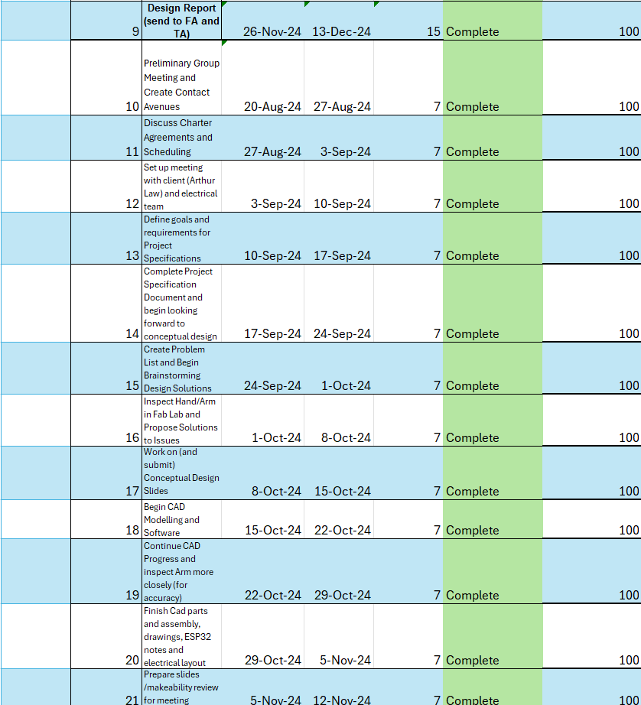

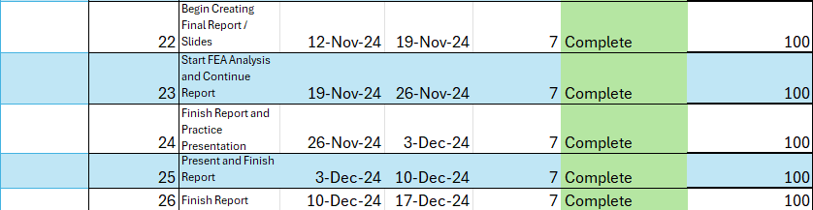

*Table 2: Deadline Gantt Chart.*

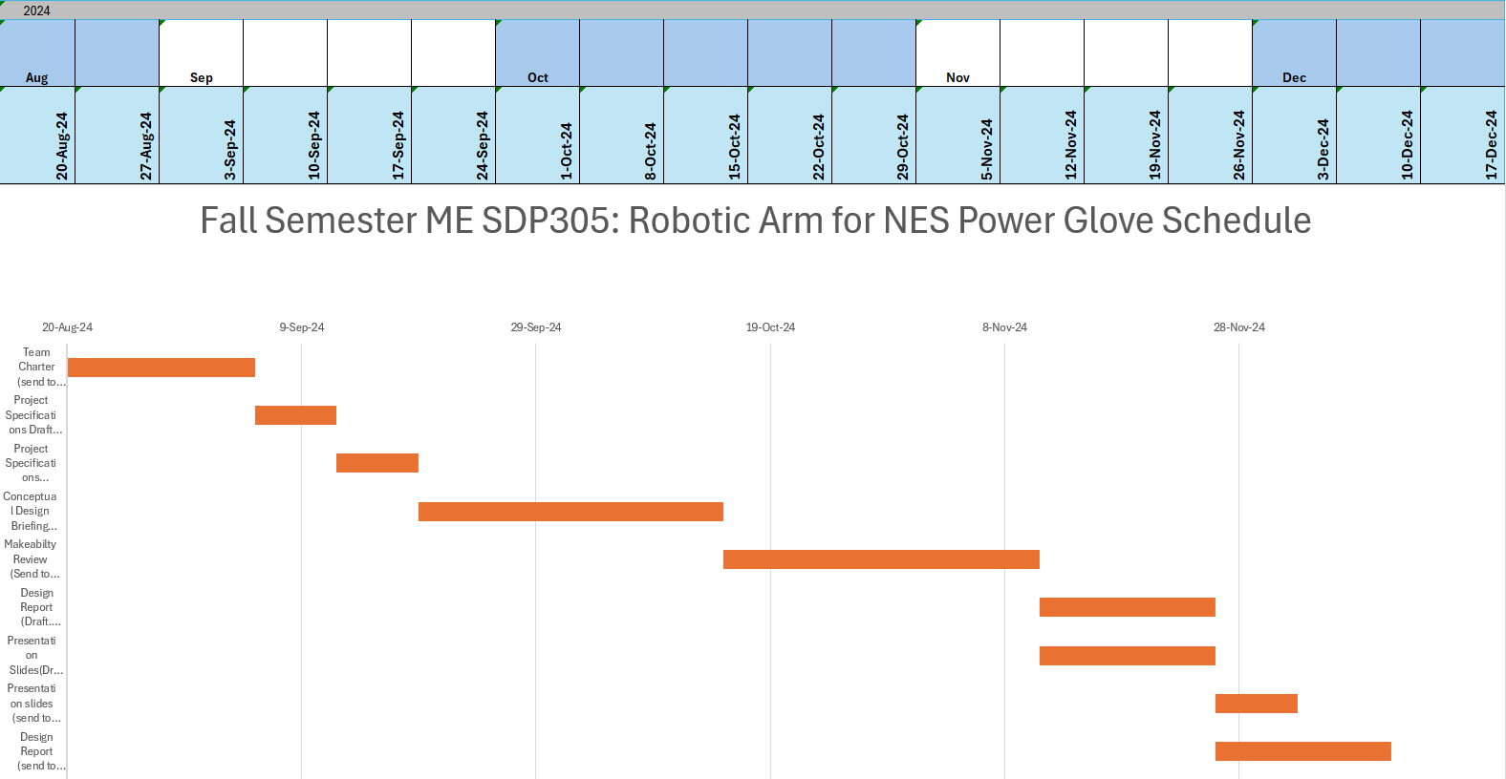

*Figure 36: Weekly task Gantt Chart.*

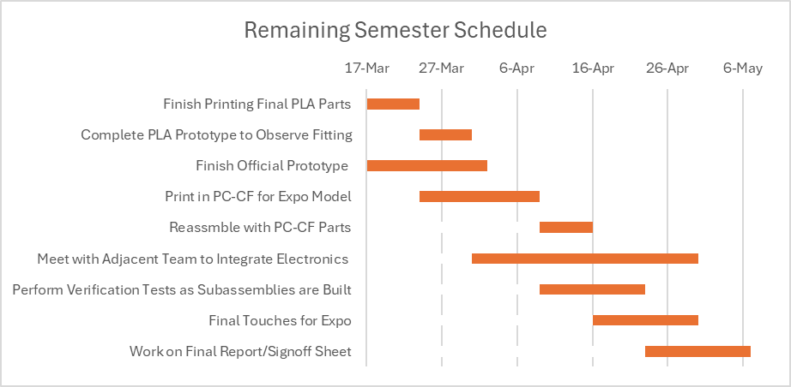

*Table 37: Spring Semester Deliverables*

**6.2 Finances**

The finance table shown below in Table 5 was used to document all purchased and custom parts to make sure the total does not exceed the allotted budget of $1,000. Expenses currently sit at $282, leaving $718 in the remaining budget, not accounting for tax or additional costs. This remaining budget will be needed should prototyping and testing in the spring result in needing new parts.

| **Parts** | **Materials** | **Cost** | **Vendors** |
| --- | --- | --- | --- |
| 2 60 kg Servos | Aluminum Casing | $72 | [Amazon](https://www.amazon.com/ANNIMOS-Digital-Voltage-Stainless-Waterproof/dp/B07KTS4L94?source=ps-sl-shoppingads-lpcontext&ref_=fplfs&psc=1&smid=A3NMC7084N0TIJ) |
| 5 12 kg Servos | Aluminum Casing | $125 | [Amazon](https://www.amazon.com/Readytosky-Degree-Standard-Digital-Steering/dp/B088H5369M?source=ps-sl-shoppingads-lpcontext&ref_=fplfs&psc=1&smid=A1LU71BLX914GS) |
| 3D Printing (fingers, hand, forearm, shoulder) | Polycarbonate Carbon Fiber Composite filament | $0 | N/A |
| Stainless Steel Gears | Stainless Steel | $9 | [Injora](https://www.injora.com/products/injora-stainless-steel-portal-gears-set-for-1-18-redcat-ascent-18?currency=USD&variant=48979512983839&utm_source=google&utm_medium=cpc&utm_campaign=Google%20Shopping&stkn=cacadfb8c118&srsltid=AfmBOopG0Kibpm1Tb97jNcuXKehCJdicmFrvBtKfjX7L1JUmLwx2c8DZfsg) |
| Brass Inserts Bulk Kit | Brass | $10 | [Amazon](https://www.amazon.com/Zuorery-Threaded-Assortment-Printing-Components/dp/B0D1CGC18H/ref=asc_df_B0D1CGC18H?mcid=30645edfbb993e14a0f56740bcd5f04a&tag=hyprod-20&linkCode=df0&hvadid=693637112524&hvpos=&hvnetw=g&hvrand=14094436408312776266&hvpone=&hvptwo=&hvqmt=&hvdev=c&hvdvcmdl=&hvlocint=&hvlocphy=9005396&hvtargid=pla-2317224951788&psc=1) |
| M3 Screw Kit | Stainless Steel | $10 | [Amazon](https://www.amazon.com/Assortment-Stainless-Replacement-Machine-Fastener/dp/B0BMQFHDBH/ref=asc_df_B0BMQFHDBH?mcid=7b31963d0cc336868d87bfdecb2670aa&tag=hyprod-20&linkCode=df0&hvadid=709832709312&hvpos=&hvnetw=g&hvrand=14608480026327625712&hvpone=&hvptwo=&hvqmt=&hvdev=c&hvdvcmdl=&hvlocint=&hvlocphy=9005396&hvtargid=pla-2245734308611&psc=1) |
| 4.5 kg Weight in Base | Cast Iron | $16 | [Amazon](https://www.amazon.com/Yes4All-Standard-1-inch-Hole-Weight-Plates/dp/B00IHM82US/ref=sr_1_31_sspa?crid=RAOCGZXNAZQX&dib=eyJ2IjoiMSJ9._JkrNFXyaH_EAWMCLAYzLJIoaea5VIM5kMSF4w5AuQy8TRzhHLoOCXeDMKyjLdYgurkXS2_JK-N4SkKChYnIQGY_XK3_Sg-qBu1GqqtGxTuq5iYFMltf91v8fjpIH0DKQypCiNSCmDgvqypnb32PN3gUVU86b5nfs3NEBsA1iIX5JA0U_qjrsPJLDSsmme8ojQU6Ks4JVZKux4SJOLP2dNCHQbNmWU3rceFFu67cEvgI4XTvmq3mTfmZk3s_Tbjl9es0SxDTyDulAR0sCda9-gvtHT07xxsPJ8hqnX35tFY.2VOkR8pzN1Al15yMWPxpqRfzIQvIcC7kUx96IKcwYnw&dib_tag=se&keywords=5%2Bkg%2Bweight%2Bplate%2Bsmall&qid=1731541879&s=sporting-goods&sprefix=5%2Bkg%2Bweight%2Bplate%2Bsmall%2Csporting%2C70&sr=1-31-spons&sp_csd=d2lkZ2V0TmFtZT1zcF9idGY&th=1) |
| M4X20 Screws | Stainless Steel | $7 | [Amazon](https://www.amazon.com/uxcell-M4x20mm-Phillips-Stainless-Fasteners/dp/B07MF41YYP/ref=sr_1_3?crid=19OQ4VGG7TDLN&dib=eyJ2IjoiMSJ9.4UwGukJQQdt4HfcTAr8YOaqAIe_MfiFuLqYxXdHjiJ2zfvD-dTM1DFUU70UI4Oudwbt-DGebNyQxGwVS7ftkbRaBL3yLtwbJLzlSht-zyiGZu5uWTmy2DYuPF-ZrLAMvs5VtEeYn51h_1U8qC7S80IZgzwiOE8l95mxyADKRb8o5reO_cPyLzSavaqDdnqxmk3elChZ1_-JmKOnbFIuiBRQ-fk5Lg5cWYb1P1f734I8.VRlUlmXY8mBmHsvDEsXIX8c0U1eVyGMDZHzM7RUN2Vk&dib_tag=se&keywords=m4x20%2Bscrew&qid=1731558703&sprefix=m4x20%2Bscrew%2Caps%2C84&sr=8-3&th=1) |
| Braided Fishing Line | Dyneema fiber, fluoropolymer coating | $9 | [Amazon](https://www.amazon.com/SpiderWire-Superline-Freshwater-Saltwater-Environments/dp/B00LDYM9OC?tag=camdenxfas-20&th=1&psc=1) |
| 20 AWG High Flex Wire | Silicone exterior, copper interior | $11 | [Amazon](https://www.amazon.com/BNTECHGO-Silicone-Flexible-Resistant-Insulation/dp/B09X473VHW/ref=sr_1_1_sspa?crid=LEG06BBIFM25&dib=eyJ2IjoiMSJ9.YGJAYtLy_Y4PYRo8XVqvPnBmVHmQ726XnAh7O8wEvTiZDlViTTBp1R1zePP17VIi5qJMELLwEblhkdUu28DBo85ZPKkD5b8ozq44Waki11Djb-NK8N5Y1uKQMtObsdmG5LClE2m8heEX-im-aCm6YR2dSUI9Q3OTo6kn6EtvWtDJRUuHrriiG1DCSzMZIuFklL2ZrX80zN3Fxmo7JEAtEXDFT7y-KWHTAmzdM3XcWQheNeVaC8AjlYsu0hPbQMEy2gdnz6o5DiFXl32osiI-Wq0FDETA1O8b-No4iwnosLk.HJnilUapSWAtkJKohBt36yzvXwPpZRhjoez2KbjT1So&dib_tag=se&keywords=20%2Bawg%2Bhigh%2Bflex%2Bsilicone%2Bwire&qid=1732246215&sprefix=20%2Bawg%2Bhigh%2Bflex%2Bsilicone%2Bwire%2Caps%2C79&sr=8-1-spons&sp_csd=d2lkZ2V0TmFtZT1zcF9hdGY&th=1) |
| Bulk Screw Sleeve Insert Kit | Stainless Steel | $13 | [Amazon](https://www.amazon.com/Stainless-Assortment-Helical-Threaded-Inserts/dp/B0CNQ85MPH?gQT=1) |
| Ball Bearings | Carbon Steel | $9.79 | [Amazon](https://www.amazon.com/uxcell-100pcs-Bearing-Precision-Polished/dp/B0B5PL6T17/ref=sr_1_3?crid=1EQTRDYTBRX74&dib=eyJ2IjoiMSJ9.1pRNnh1MW1CR6_XfkedIsnI7U83pWN-Rxa6Usi449JJHZzcBJHHCq7nKoPQYArbutckckOsmYOZcvv0-amSZAklh2F8ITFumedltSXu9oAlBwdnR-4_exCO9Ov0-KOStGV65vmmvLPznXiaEkfxyvxC1xnhxT-CE7HesK9W3FlD8ylNkXqvr-5g4aMNkXU8VOO4ESnA6y6ZE_T67P6S6I2FQUPF0p3yNrQ5rq89qcYg.J8CeEJhNXRJx5lUBpZjnctrOZsQaTbECkXezDKZuV0g&dib_tag=se&keywords=uxcell%2B100%2Bpcs%2B10%2Bmm%2Bcarbon%2Bsteel%2Bbearing%2Bballs&qid=1746670600&sprefix=uxcell%2B100%2Bpcs%2B10%2Bmm%2Bcarbon%2Bsteel%2Bbearing%2Bball%2Caps%2C81&sr=8-3&th=1) |
| Male Pins | PA 6 | $0.91 | [Digikey](https://www.digikey.com/en/products/detail/jst-sales-america-inc/B3B-XH-A/1651046) |
| 3 Position Amp Connectors | PA 66 | $6.40 | [Digikey](https://www.digikey.com/en/products/detail/te-connectivity-amp-connectors/282837-3/2187974) |
| 2 Position Amp Connectors | PA 66 | $1.92 | [Digikey](https://www.digikey.com/en/products/detail/te-connectivity-amp-connectors/282837-2/2187973) |
| DC Power Supply | Aluminium | $66 | [Amazon](https://www.amazon.com/dp/B0C17NLZNH/?coliid=I3K0YDRTZO7VIQ&colid=1QX8D4EYEDMJV&ref_=_sed_dp&th=1) |
| PCB | Copper | $8.40 | [JLCPCB](https://jlcpcb.com/?from=VGSU&utm_source=google&utm_medium=cpc&utm_campaign=14179457750&gad_source=1&gad_campaignid=14179457750&gbraid=0AAAAABS1QqncpkjkYKOe2W_UaXrphoKEN&gclid=CjwKCAjwiezABhBZEiwAEbTPGLeREkpPaq_RH4bFiD4fyp-oLUDlVGWutSVjmFEd3AHD26BG0WMQqhoCxa8QAvD_BwE) |
| **TOTAL** |  | **$375.42** |  |

*Table 2: Budget Table*

**7. Social Impact**

This arm prototype, as it is currently not finalized and not ready for display use by TechWorks!, will serve as a building block to be used further by next year’s SDP group to get closer to TechWorks!’s desired final product. Because of the planned simplicity in construction and deconstruction of this prototype, along with assembly and disassembly instructions, parts of this arm should be used by next year’s group to both save material and money.

The final working version of this robotic arm, as will be created by future groups, will serve to be an educational tool for the public visitors of TechWorks! museum in order to learn more about the technological and cultural touchstone that is the NES Power Glove. It also serves to protect the NES Power Glove from damage by museum visitors, saving TechWorks!’s limited supply of rare technology and thus saving TechWorks! money.

**8. References**

[1] *Aluminum 6061-T6; 6061-T651*. (n.d.). Retrieved from ASM Aerospace Specifications Metals: https://asm.matweb.com/search/specificmaterial.asp?bassnum=ma6061t6

[2] Khan, T. (2024, July 25). *Aluminum: Advantages and Properties of Aluminum*. Retrieved from AZO Materials: https://www.azom.com/article.aspx?ArticleID=1446

[3] Marilyn L. Minus, S. K. (2005). *The Processing, Properties, and Structure of Carbon Fibers.* Atlanta: Georgia Institute of Technology,.

[4] *Stainless Steel - Grade 304 (UNS S30400)*. (2021, October 23). Retrieved from AZO Material: https://www.azom.com/properties.aspx?ArticleID=965

Bandar Almeshari, Harri Junaedi, Muneer Baig, Abdulhakim Almajid,

[5] Development of 3D printing short carbon fiber reinforced polypropylene composite filaments, Journal of Materials Research and Technology, Volume 24, 2023,

Pages 16-26, ISSN 2238-7854, https://doi.org/10.1016/j.jmrt.2023.02.198.

[6] “Thermoplastics - Physical Properties,” *Engineeringtoolbox.com*, 2019. https://www.engineeringtoolbox.com/physical-properties-thermoplastics-d_808.html

[7] “InMoov – open-source 3D printed life-size robot.” https://inmoov.fr/

[8] “New Powerglove for sale | eBay,” *eBay*, 2024. https://www.ebay.com/sch/i.html?_from=R40&_trksid=p2332490.m570.l1313&_nkw=new+powerglove&_sacat=0 (accessed Dec. 14, 2024).

‌[9] Ganesh Anitha Palanivel, R., Krueger, M., Marzan, N., Milham, J.,“ME SDP 305 Robotic Arm for NES Power Glove Integration and Test Plan Procedures,” (2025, February 19)

**Appendix A: Design Makeability Review Checklist**

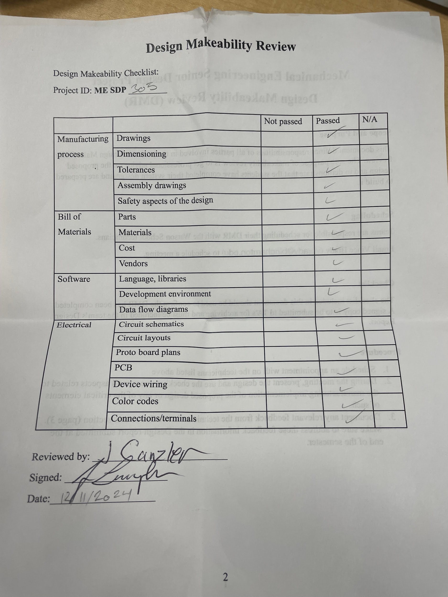

**Appendix B: Finance Table**

| **Parts** | **Materials** | **Cost** | **Vendors** |
| --- | --- | --- | --- |
| 2 60 kg Servos | Aluminum Casing | $72 | [Amazon](https://www.amazon.com/ANNIMOS-Digital-Voltage-Stainless-Waterproof/dp/B07KTS4L94?source=ps-sl-shoppingads-lpcontext&ref_=fplfs&psc=1&smid=A3NMC7084N0TIJ) |
| 5 12 kg Servos | Aluminum Casing | $125 | [Amazon](https://www.amazon.com/Readytosky-Degree-Standard-Digital-Steering/dp/B088H5369M?source=ps-sl-shoppingads-lpcontext&ref_=fplfs&psc=1&smid=A1LU71BLX914GS) |
| 3D Printing (fingers, hand, forearm, shoulder) | Polycarbonate Carbon Fiber Composite filament | $0 | N/A |
| Stainless Steel Gears | Stainless Steel | $9 | [Injora](https://www.injora.com/products/injora-stainless-steel-portal-gears-set-for-1-18-redcat-ascent-18?currency=USD&variant=48979512983839&utm_source=google&utm_medium=cpc&utm_campaign=Google%20Shopping&stkn=cacadfb8c118&srsltid=AfmBOopG0Kibpm1Tb97jNcuXKehCJdicmFrvBtKfjX7L1JUmLwx2c8DZfsg) |
| Brass Inserts Bulk Kit | Brass | $10 | [Amazon](https://www.amazon.com/Zuorery-Threaded-Assortment-Printing-Components/dp/B0D1CGC18H/ref=asc_df_B0D1CGC18H?mcid=30645edfbb993e14a0f56740bcd5f04a&tag=hyprod-20&linkCode=df0&hvadid=693637112524&hvpos=&hvnetw=g&hvrand=14094436408312776266&hvpone=&hvptwo=&hvqmt=&hvdev=c&hvdvcmdl=&hvlocint=&hvlocphy=9005396&hvtargid=pla-2317224951788&psc=1) |
| M3 Screw Kit | Stainless Steel | $10 | [Amazon](https://www.amazon.com/Assortment-Stainless-Replacement-Machine-Fastener/dp/B0BMQFHDBH/ref=asc_df_B0BMQFHDBH?mcid=7b31963d0cc336868d87bfdecb2670aa&tag=hyprod-20&linkCode=df0&hvadid=709832709312&hvpos=&hvnetw=g&hvrand=14608480026327625712&hvpone=&hvptwo=&hvqmt=&hvdev=c&hvdvcmdl=&hvlocint=&hvlocphy=9005396&hvtargid=pla-2245734308611&psc=1) |
| 4.5 kg Weight in Base | Cast Iron | $16 | [Amazon](https://www.amazon.com/Yes4All-Standard-1-inch-Hole-Weight-Plates/dp/B00IHM82US/ref=sr_1_31_sspa?crid=RAOCGZXNAZQX&dib=eyJ2IjoiMSJ9._JkrNFXyaH_EAWMCLAYzLJIoaea5VIM5kMSF4w5AuQy8TRzhHLoOCXeDMKyjLdYgurkXS2_JK-N4SkKChYnIQGY_XK3_Sg-qBu1GqqtGxTuq5iYFMltf91v8fjpIH0DKQypCiNSCmDgvqypnb32PN3gUVU86b5nfs3NEBsA1iIX5JA0U_qjrsPJLDSsmme8ojQU6Ks4JVZKux4SJOLP2dNCHQbNmWU3rceFFu67cEvgI4XTvmq3mTfmZk3s_Tbjl9es0SxDTyDulAR0sCda9-gvtHT07xxsPJ8hqnX35tFY.2VOkR8pzN1Al15yMWPxpqRfzIQvIcC7kUx96IKcwYnw&dib_tag=se&keywords=5%2Bkg%2Bweight%2Bplate%2Bsmall&qid=1731541879&s=sporting-goods&sprefix=5%2Bkg%2Bweight%2Bplate%2Bsmall%2Csporting%2C70&sr=1-31-spons&sp_csd=d2lkZ2V0TmFtZT1zcF9idGY&th=1) |
| M4X20 Screws | Stainless Steel | $7 | [Amazon](https://www.amazon.com/uxcell-M4x20mm-Phillips-Stainless-Fasteners/dp/B07MF41YYP/ref=sr_1_3?crid=19OQ4VGG7TDLN&dib=eyJ2IjoiMSJ9.4UwGukJQQdt4HfcTAr8YOaqAIe_MfiFuLqYxXdHjiJ2zfvD-dTM1DFUU70UI4Oudwbt-DGebNyQxGwVS7ftkbRaBL3yLtwbJLzlSht-zyiGZu5uWTmy2DYuPF-ZrLAMvs5VtEeYn51h_1U8qC7S80IZgzwiOE8l95mxyADKRb8o5reO_cPyLzSavaqDdnqxmk3elChZ1_-JmKOnbFIuiBRQ-fk5Lg5cWYb1P1f734I8.VRlUlmXY8mBmHsvDEsXIX8c0U1eVyGMDZHzM7RUN2Vk&dib_tag=se&keywords=m4x20%2Bscrew&qid=1731558703&sprefix=m4x20%2Bscrew%2Caps%2C84&sr=8-3&th=1) |
| Braided Fishing Line | Dyneema fiber, fluoropolymer coating | $9 | [Amazon](https://www.amazon.com/SpiderWire-Superline-Freshwater-Saltwater-Environments/dp/B00LDYM9OC?tag=camdenxfas-20&th=1&psc=1) |
| 20 AWG High Flex Wire | Silicone exterior, copper interior | $11 | [Amazon](https://www.amazon.com/BNTECHGO-Silicone-Flexible-Resistant-Insulation/dp/B09X473VHW/ref=sr_1_1_sspa?crid=LEG06BBIFM25&dib=eyJ2IjoiMSJ9.YGJAYtLy_Y4PYRo8XVqvPnBmVHmQ726XnAh7O8wEvTiZDlViTTBp1R1zePP17VIi5qJMELLwEblhkdUu28DBo85ZPKkD5b8ozq44Waki11Djb-NK8N5Y1uKQMtObsdmG5LClE2m8heEX-im-aCm6YR2dSUI9Q3OTo6kn6EtvWtDJRUuHrriiG1DCSzMZIuFklL2ZrX80zN3Fxmo7JEAtEXDFT7y-KWHTAmzdM3XcWQheNeVaC8AjlYsu0hPbQMEy2gdnz6o5DiFXl32osiI-Wq0FDETA1O8b-No4iwnosLk.HJnilUapSWAtkJKohBt36yzvXwPpZRhjoez2KbjT1So&dib_tag=se&keywords=20%2Bawg%2Bhigh%2Bflex%2Bsilicone%2Bwire&qid=1732246215&sprefix=20%2Bawg%2Bhigh%2Bflex%2Bsilicone%2Bwire%2Caps%2C79&sr=8-1-spons&sp_csd=d2lkZ2V0TmFtZT1zcF9hdGY&th=1) |
| Bulk Screw Sleeve Insert Kit | Stainless Steel | $13 | [Amazon](https://www.amazon.com/Stainless-Assortment-Helical-Threaded-Inserts/dp/B0CNQ85MPH?gQT=1) |
| Ball Bearings | Carbon Steel | $9.79 | [Amazon](https://www.amazon.com/uxcell-100pcs-Bearing-Precision-Polished/dp/B0B5PL6T17/ref=sr_1_3?crid=1EQTRDYTBRX74&dib=eyJ2IjoiMSJ9.1pRNnh1MW1CR6_XfkedIsnI7U83pWN-Rxa6Usi449JJHZzcBJHHCq7nKoPQYArbutckckOsmYOZcvv0-amSZAklh2F8ITFumedltSXu9oAlBwdnR-4_exCO9Ov0-KOStGV65vmmvLPznXiaEkfxyvxC1xnhxT-CE7HesK9W3FlD8ylNkXqvr-5g4aMNkXU8VOO4ESnA6y6ZE_T67P6S6I2FQUPF0p3yNrQ5rq89qcYg.J8CeEJhNXRJx5lUBpZjnctrOZsQaTbECkXezDKZuV0g&dib_tag=se&keywords=uxcell%2B100%2Bpcs%2B10%2Bmm%2Bcarbon%2Bsteel%2Bbearing%2Bballs&qid=1746670600&sprefix=uxcell%2B100%2Bpcs%2B10%2Bmm%2Bcarbon%2Bsteel%2Bbearing%2Bball%2Caps%2C81&sr=8-3&th=1) |
| Male Pins | PA 6 | $0.91 | [Digikey](https://www.digikey.com/en/products/detail/jst-sales-america-inc/B3B-XH-A/1651046) |
| 3 Position Amp Connectors | PA 66 | $6.40 | [Digikey](https://www.digikey.com/en/products/detail/te-connectivity-amp-connectors/282837-3/2187974) |
| 2 Position Amp Connectors | PA 66 | $1.92 | [Digikey](https://www.digikey.com/en/products/detail/te-connectivity-amp-connectors/282837-2/2187973) |
| DC Power Supply | Aluminium | $66 | [Amazon](https://www.amazon.com/dp/B0C17NLZNH/?coliid=I3K0YDRTZO7VIQ&colid=1QX8D4EYEDMJV&ref_=_sed_dp&th=1) |
| PCB | Copper | $8.40 | [JLCPCB](https://jlcpcb.com/?from=VGSU&utm_source=google&utm_medium=cpc&utm_campaign=14179457750&gad_source=1&gad_campaignid=14179457750&gbraid=0AAAAABS1QqncpkjkYKOe2W_UaXrphoKEN&gclid=CjwKCAjwiezABhBZEiwAEbTPGLeREkpPaq_RH4bFiD4fyp-oLUDlVGWutSVjmFEd3AHD26BG0WMQqhoCxa8QAvD_BwE) |
| **TOTAL** |  | **$375.42** |  |

*Table 2: Budget Table*

**Appendix C: Detailed Drawings**

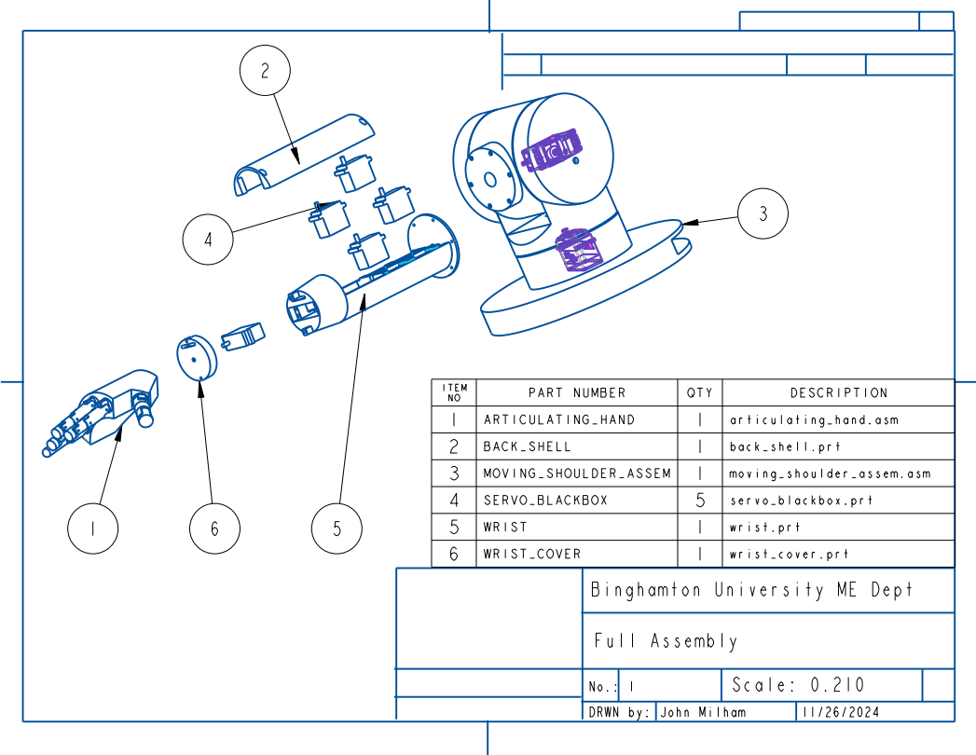

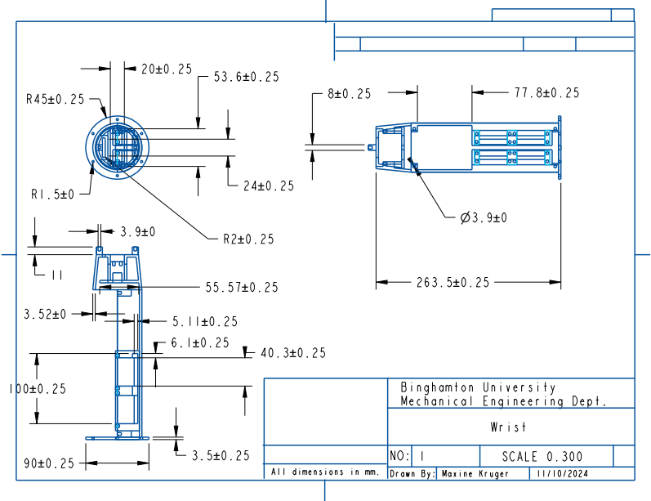

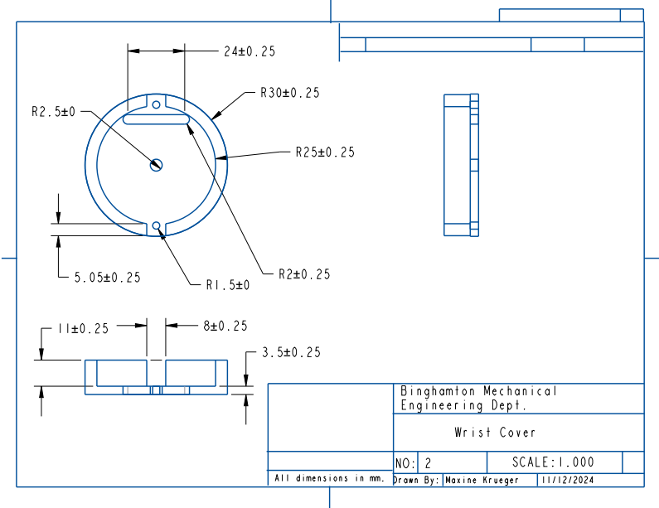

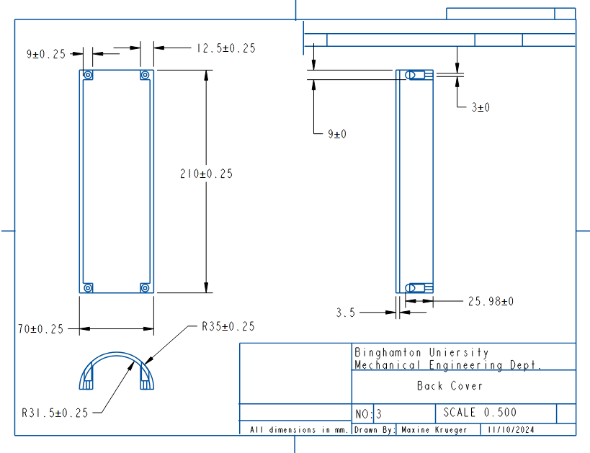

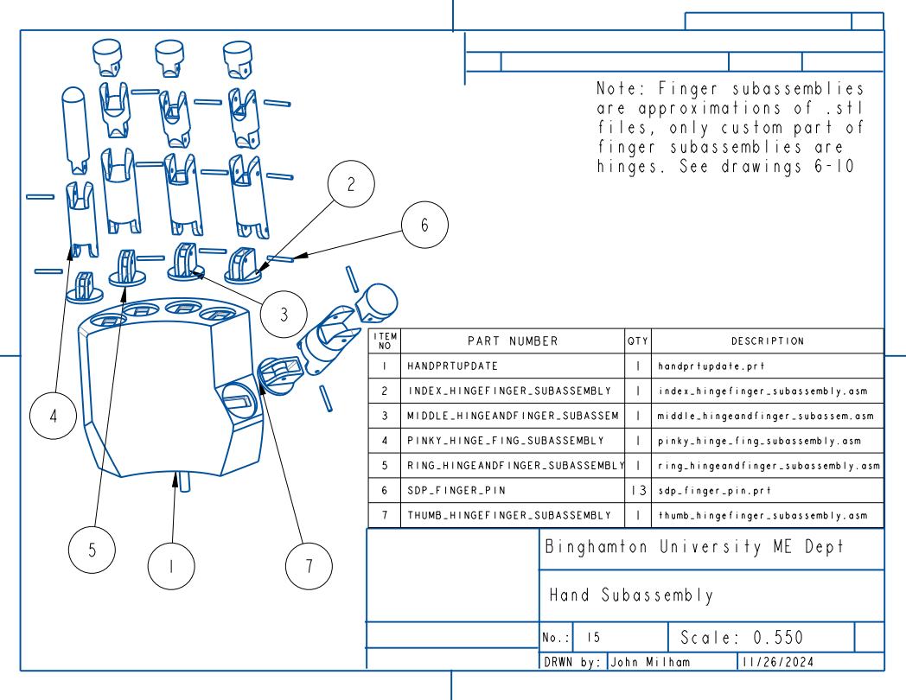

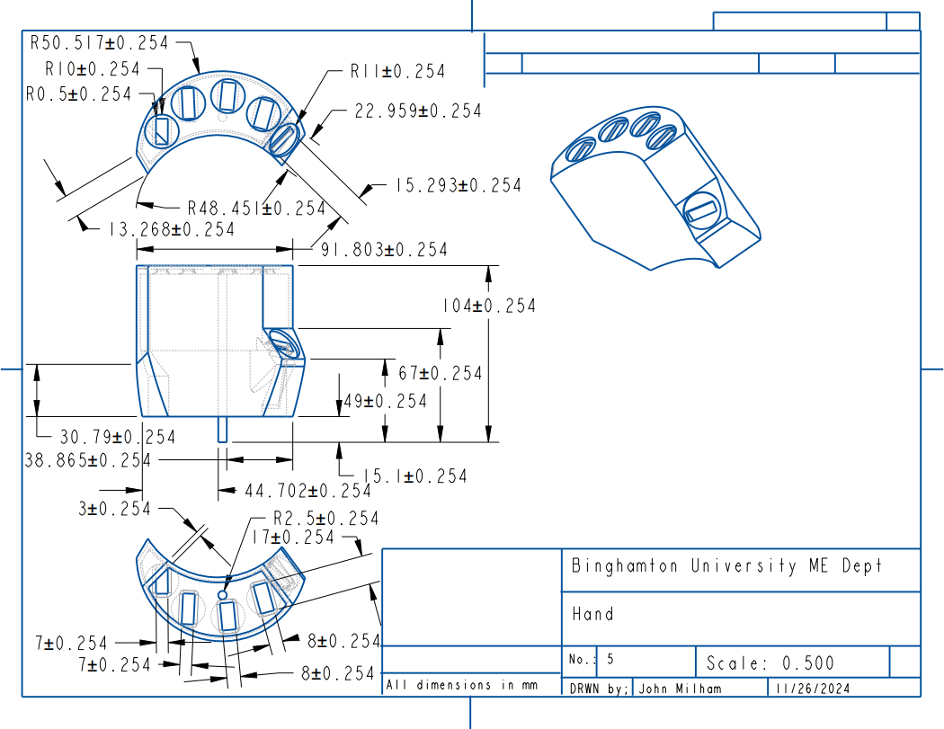

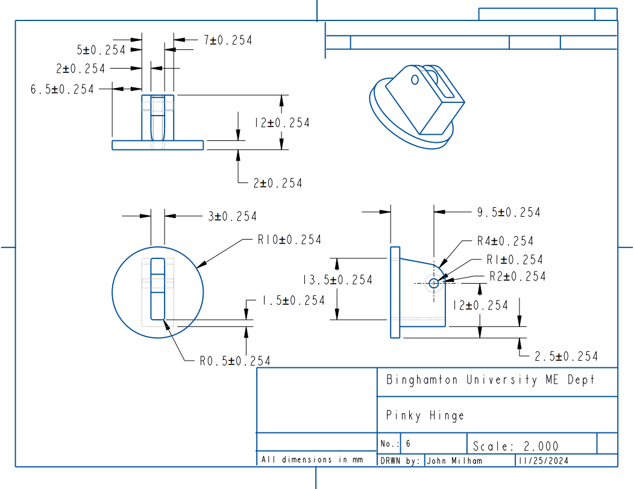

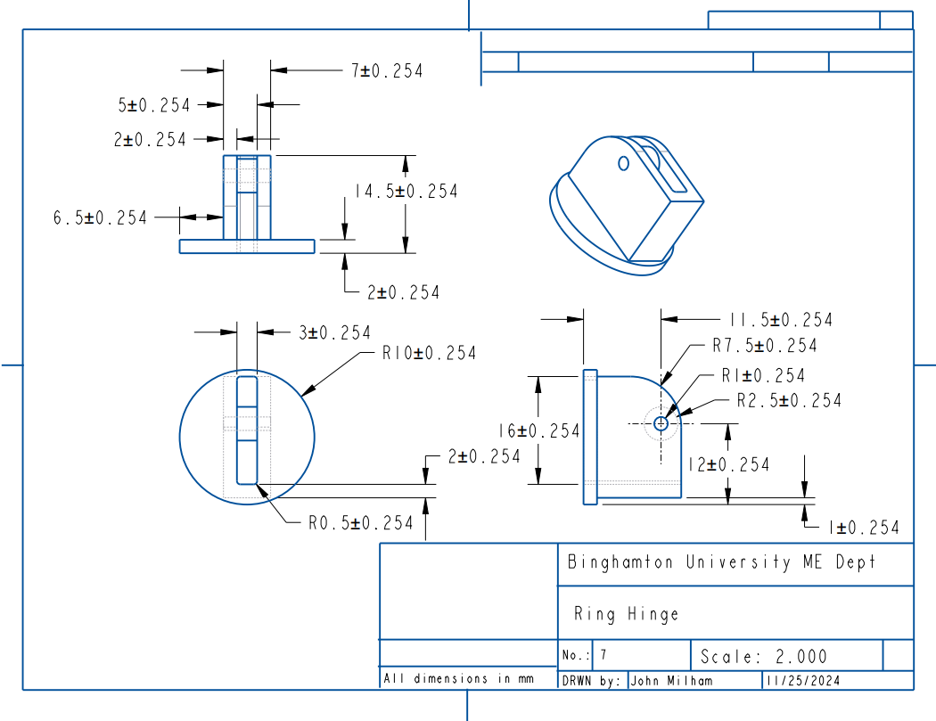

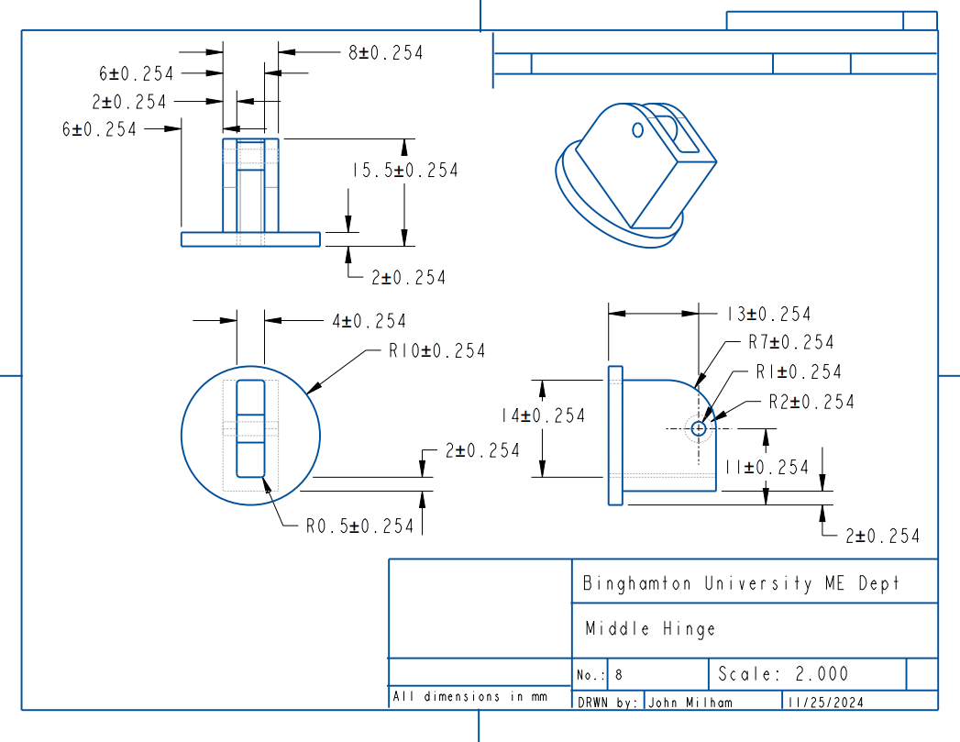

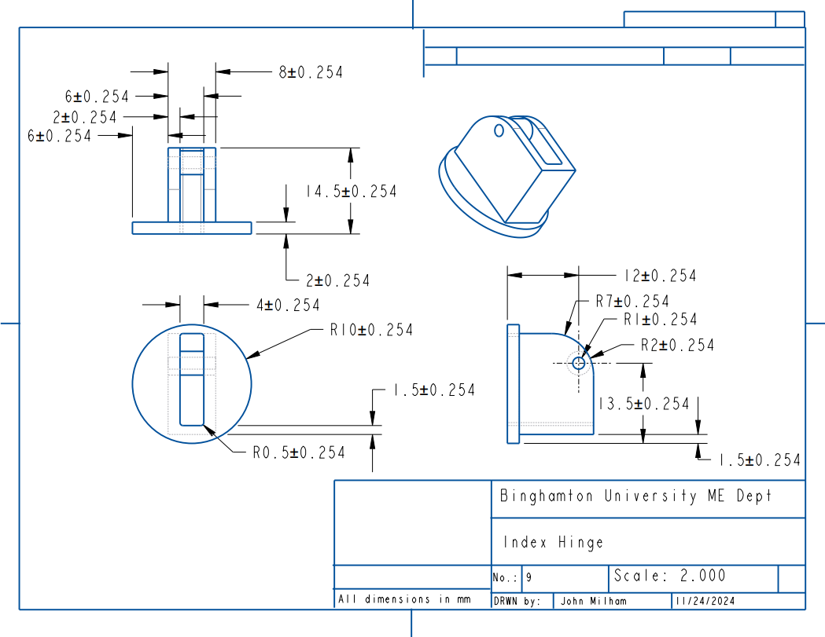

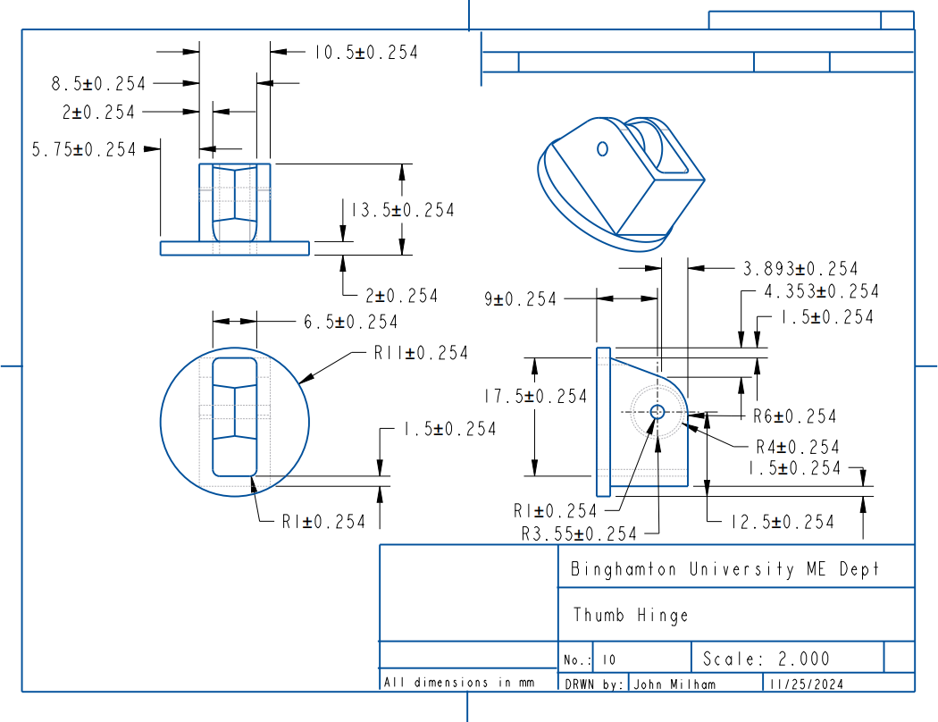

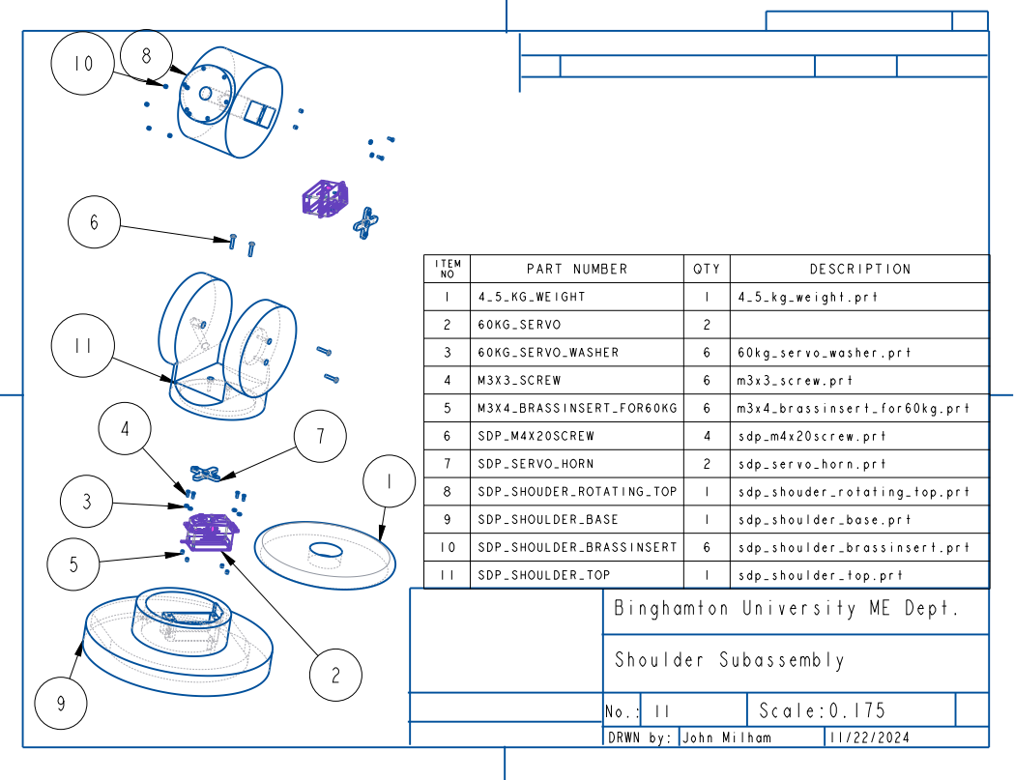

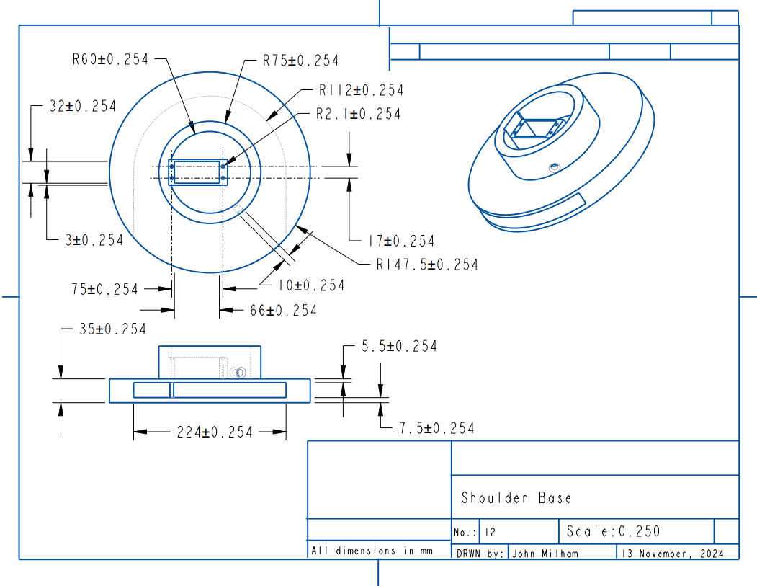

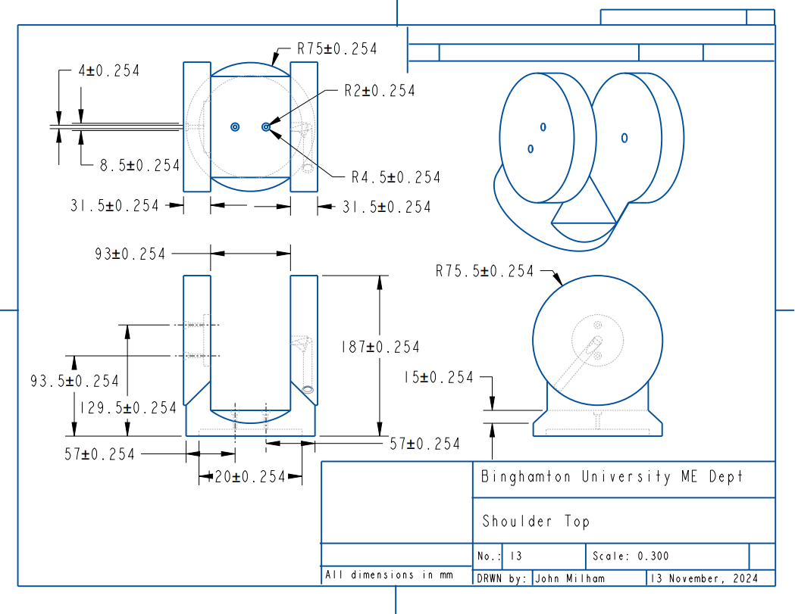

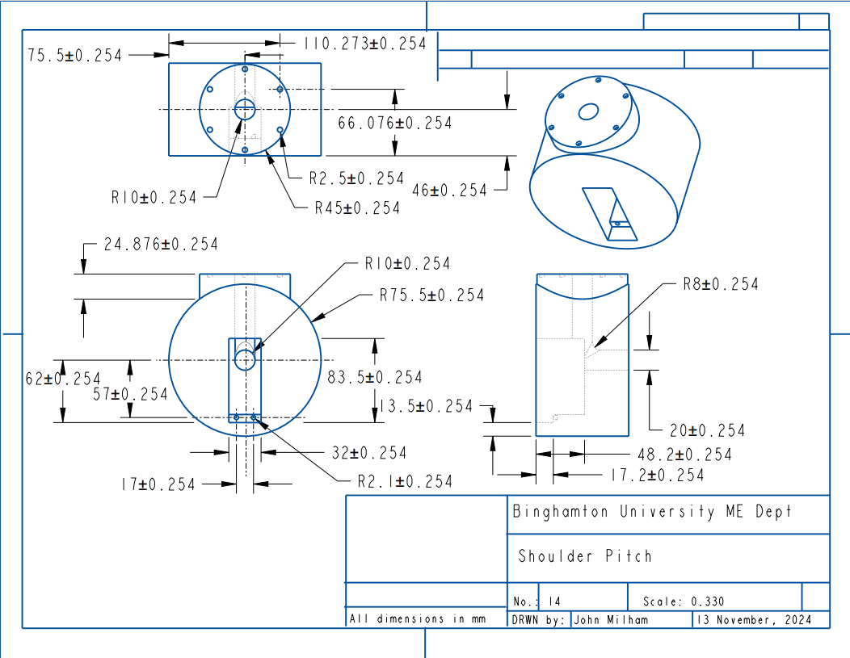

**Appendix D: Test Results**

| **Requirements** | | | | |
| --- | --- | --- | --- | --- |
| **ID** | **Brief Description** | **Verification Method** | **Tested?** | **Verified?** |
| **{**MESDP305-T-001} | Finger Extension Angle Measurement Test | [I] | Yes* | Partial |
| **{**MESDP305-T-002} | Finger Curl Angle Measurement Test | [I] | Yes* | Partial |
| **{**MESDP305-T-003} | Wrist Rotate Angle Measurement Test | [I] | Yes* | Partial |
| **{**MESDP305-T-004} | Arm Pitch Angle Measurement Test | [I] | Yes | Yes |
| **{**MESDP305-T-005} | Arm Yaw Angle Measurement Test | [I] | Yes | Partial |
| **{**MESDP305-T-006} | Glove Fitting Test | [D] | Yes | Yes |
| **{**MESDP305-T-007} | Shoulder Stabilization Test | [D] | Yes | Partial |
| **{**MESDP305-T-008} | Free Movement Test | [D] | No | No |
| **{**MESDP305-T-009} | Concealed Wires Test | [I, D] | Yes | Yes |
| **{**MESDP305-T-010} | Power Source Test | [D] | Yes | Yes |
| **{**MESDP305-T-011} | Game Response Test | [T] | No | No |
| **{**MESDP305-T-012} | Integration Test | [A,T] | No | No |
| **{**MESDP305-T-013} | Disassemble Test | [T] | Yes | Yes |
| **{**MESDP305-T-014} | Budget Test | [D] | Yes | Yes |

*Tests for these parts were conducted prior to full arm assembly, complications arose before being able to test on fully built arm

**Appendix E: Code**

**Receiver**

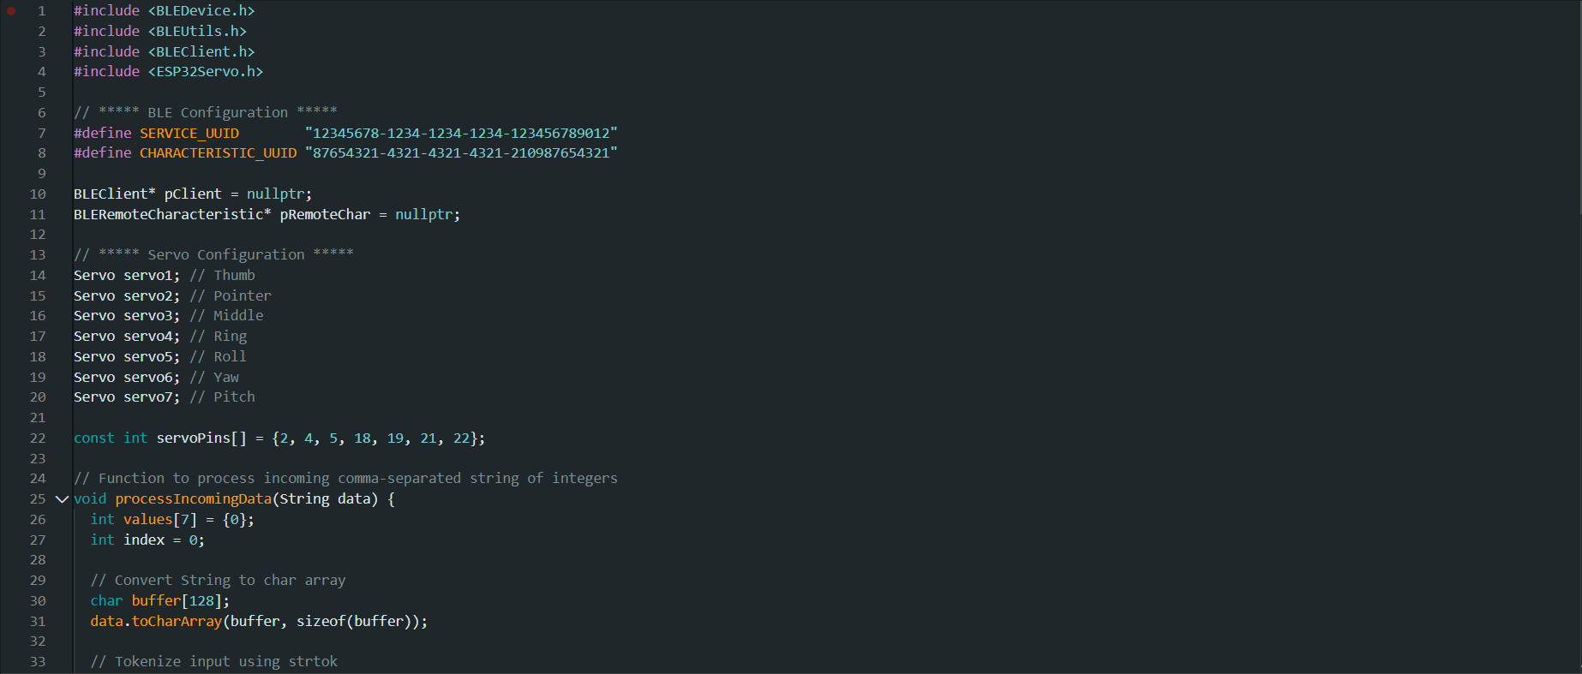

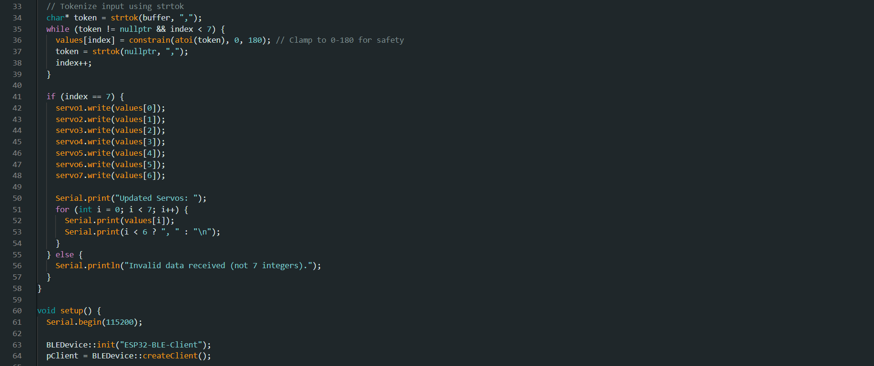

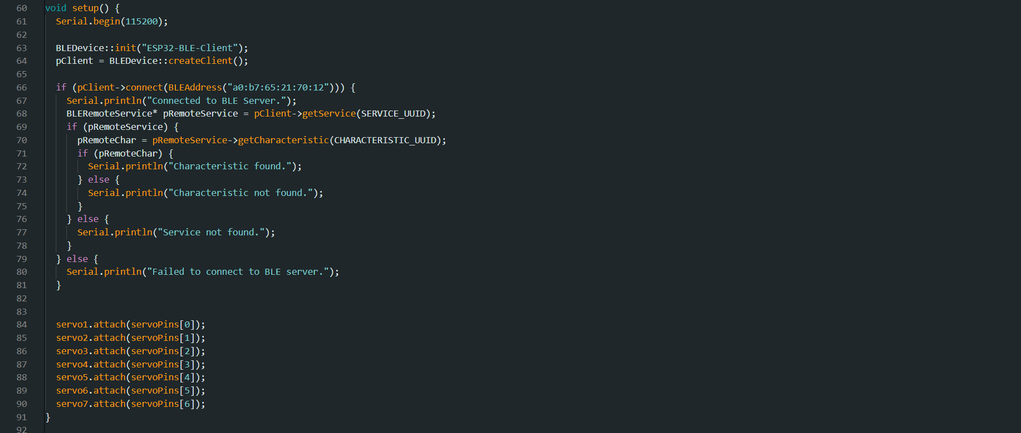

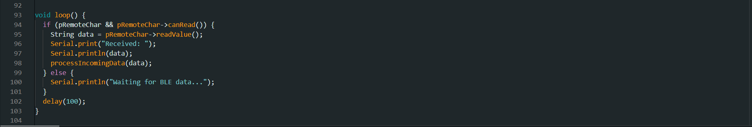

**Transmitter**

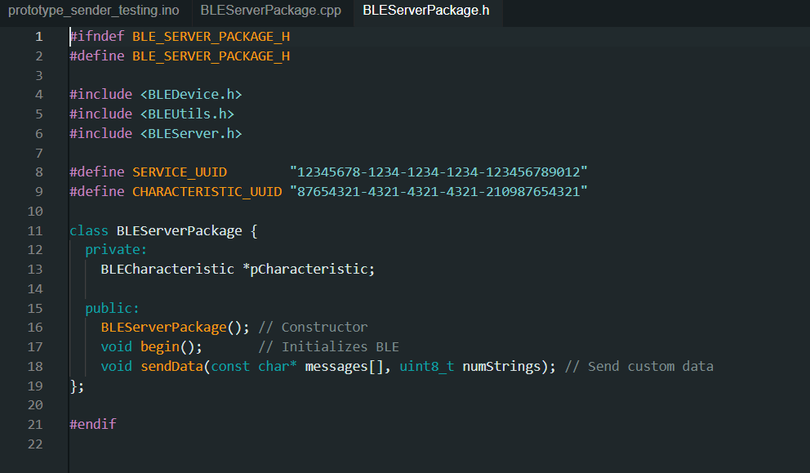

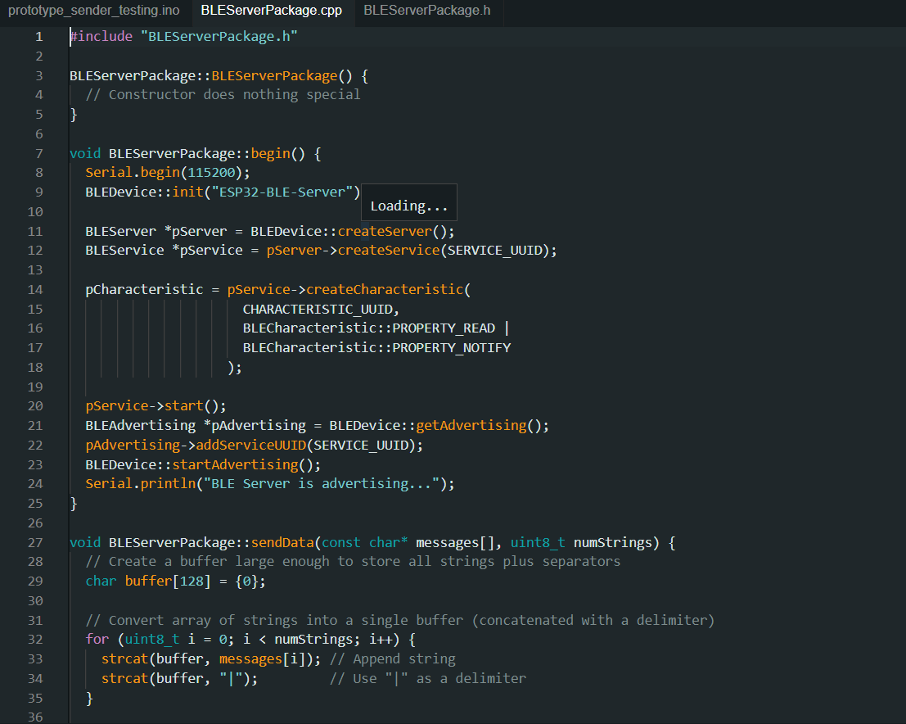

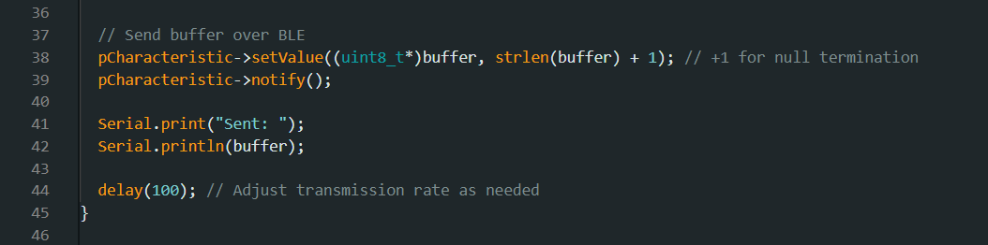

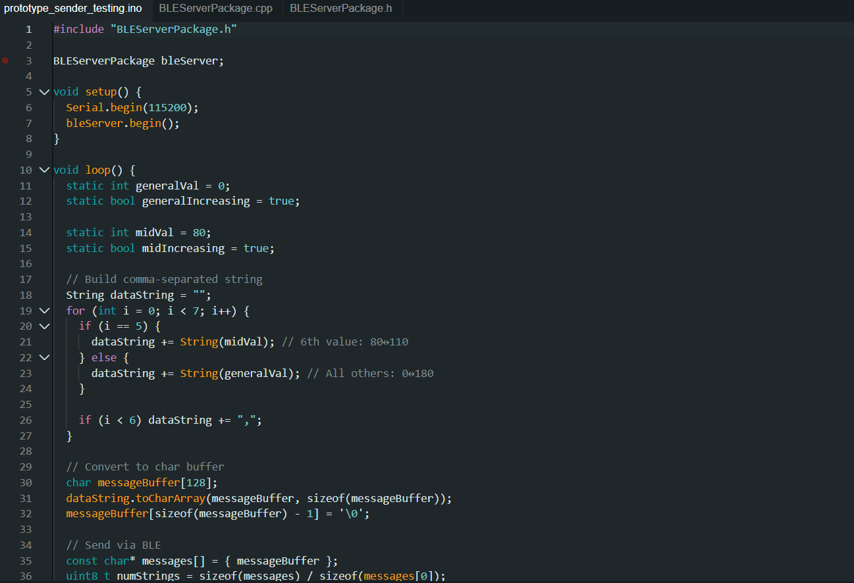

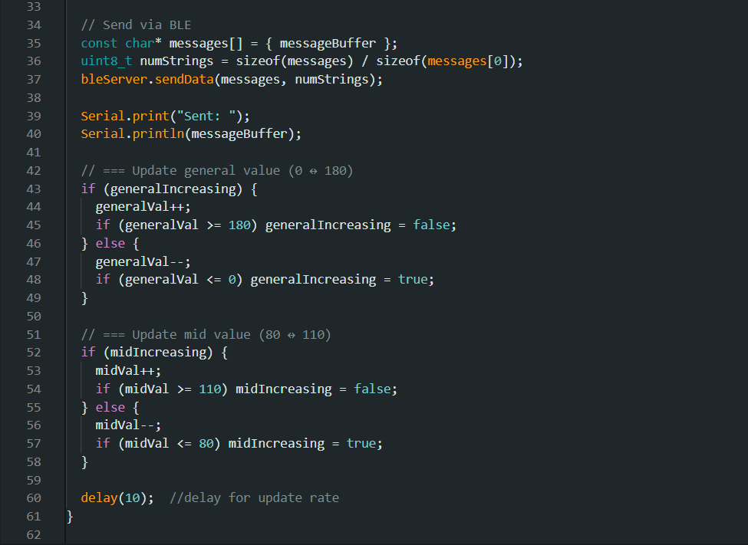

**Appendix F: PCB**

